Lecture 1 – What is Public Policy and Why Should We Care?

1. What is Public Policy?
Public policy can be understood as what governments choose to do or not to do about public problems. This definition emphasizes that inaction is also a form of policy: when governments decide not to regulate emissions, not to provide childcare, or not to intervene in markets, they are still making a decision that shapes outcomes in society.

Policies are not simply technical solutions; they are the outcome of a political process that involves both cooperation and bargaining. Policy-making always happens within a contested space where multiple actors try to influence decisions.

The study of policy focuses on:
- Polity: the institutional framework of a political system, such as whether it is a parliamentary or presidential democracy, whether it has a unicameral or bicameral legislature, or whether constitutional review exists. These rules shape how policies can be made.
- Politics: the process of decision-making under conditions of conflict and scarcity. Harold Lasswell famously captured this dynamic with the phrase “who gets what, when, how.” Politics reflects the struggles among individuals and groups over limited resources, influence, and recognition.
- Policy: the outputs of the political system, meaning the actions and non-actions governments take. These include laws, regulations, administrative guidelines, and programs.
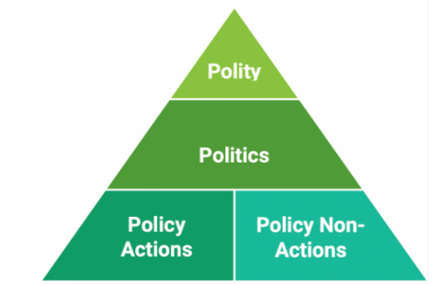

This triad highlights that to understand policy, one must look at institutions (polity), processes (politics), and substance (policy) together. Otto von Bismarck’s quote that “laws are like sausages, it is better not to see them being made” reflects the often messy and conflictual reality of how policies emerge.

2. Key Dimensions of a Public Policy
- A general rule – applied to public issues, not just individual cases.
- Linked to action or intervention – about what governments actually do (implementation, not only planning).
- Initiated/enforced by legitimate power – government, legislature, courts, bureaucracy.
- Made through a process and instrument – specific mechanisms, often but not always public.
- Has a clear objective and impact – goals and measurable effects, subject to evaluation.

3. Outputs, Outcomes, and Impacts
Another important distinction is between the different stages of policy results:
- Output is the immediate product of decision-making (such as passing a tariff law or introducing a subsidy).
- Outcome refers to the reactions of those targeted by the policy (such as firms shifting supply chains in response to tariffs).
- Impact captures the long-term changes in society or behavior (for example higher consumer prices or the reshoring of industries due to tariffs).

The example of Donald Trump’s tariffs illustrates how these layers differ and how perspectives vary: to steelworkers, tariffs might seem like a good policy outcome because they protect jobs, but to consumers, the long-term impact of higher prices makes them a bad policy.

4. Justifying Public Policy
Governments intervene in society for three broad reasons:
- Political reasons: Governments act because citizens, interest groups, or social movements demand it. Examples include the LGBT rights movement, the anti-nuclear movement in the 1980s. Sometimes international or regional pressures, such as Europeanisation or global agreements, push governments to act as well.
- Moral reasons: Governments may act because they believe they have an obligation, even if citizens do not demand it. Examples include providing disaster relief, establishing basic social security, or offering military support to Ukraine. These decisions rest on normative judgments about what is right or just.
- Economic reasons: Governments often act to address market failures. Classic examples include:
- Lack of competition – monopolies or oligopolies reduce efficiency and fairness;
- Information asymmetries – one party in a transaction knows much more than the other, as in financial markets or healthcare;
- Externalities – costs or benefits spill over to others, such as pollution or vaccinations;
- Public goods – goods that are non-rival and non-excludable, such as clean air or national defense;

5. Equalitarian Outcomes and the Trickle-Down Effect
When governments intervene, the distribution of benefits often follows different logics:
- An equalitarian outcome occurs when resources are distributed more equally across society. An example is universal healthcare, which ensures access regardless of income.
- The trickle-down effect describes policies where benefits are concentrated at the top, with the expectation that gains will eventually spread to others. A common example is corporate tax cuts, justified on the grounds that they stimulate investment and job creation.

These two approaches reflect very different ideologies of fairness and justice. They also highlight that all policies create winners and losers, even if the distributional consequences are not always visible at first

6. Typologies (Classifications) of Public Policy
- By policy fields – grouped by sector, e.g. fiscal, environmental, health, energy, education.
- By political ideology – reflects values and worldviews, e.g. progressive vs. conservative, isolationist vs. open.
- By instruments – the concrete tools governments use:
- Regulation – decrees and rules to require or forbid behavior (e.g. environmental laws, safety standards);
- Government management – direct provision of services and resource management (e.g. education, defense, municipal services);
- Education, information, persuasion – informing or nudging citizens (e.g. disaster relief appeals, nutrition labels);
- Taxing and spending – allocation or collection of money to achieve goals (e.g. Social Security, cigarette tax);
- Market mechanisms – using incentives through markets (e.g. carbon tax, energy efficiency labeling).
↳ This connects with Hood & Margetts’ NATO scheme: nodality (information), authority (law), treasure (money), organization (direct provision).
- By governance principles – based on which resource or logic is used: persuasion, authority, money, or state provision.
- By intensity of political conflict – some policies are low conflict (distributive, e.g. subsidies), others high conflict (redistributive, e.g. welfare, taxation).
This links to Lowi’s typology.

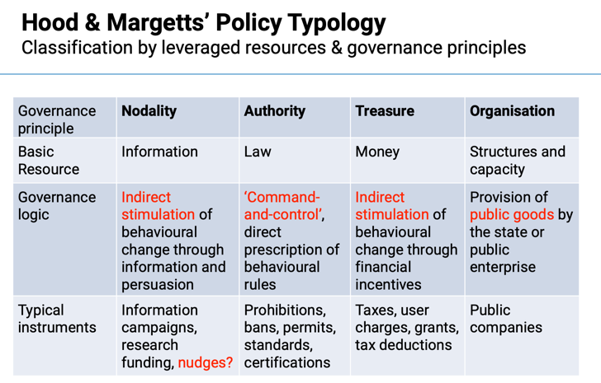
- Nodality: Uses information campaigns and education to indirectly influence behavior (e.g., health awareness programs).
- Authority: Relies on laws and regulations to directly control behavior (e.g., safety standards, mandatory schooling).
- Treasure: Uses financial resources like taxes, grants, or subsidies to incentivize specific behaviors (e.g., tax credits for renewable energy).
- Organization: Directly provides goods or services through government agencies (e.g., public schools, national defense)
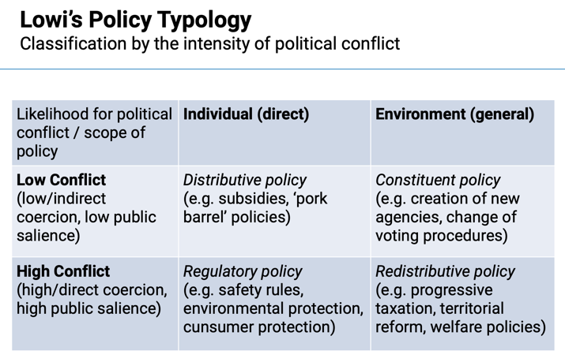
Policies differ in the level of political conflict they generate:
  - Low Conflict: Includes policies like subsidies, which don’t heavily impact any one group.
  - High Conflict: Regulatory or redistributive policies often lead to higher conflict, as they impose rules or redistribute wealth, impacting public and private interests directly.
7. Policy-Making as Problem-Solving
A social problem becomes a policy problem when elites decide to treat it as one. Since there are always more problems than resources, issues must compete for attention in the policy process. Sometimes problems are even strategically created to serve political interests.

Once a problem is recognized, it rarely disappears. Policy problems often persist because they create their own constituencies that keep them alive, and even when resolved, they tend to generate new issues. For instance, improving the health of the elderly may lead to new pension-related challenges.
Different models try to explain how policies are made:
- The Rationalist Model (Policy Cycle)

The rationalist approach views policy-making as a logical, sequential process of problem-solving – often described as the policy cycle, which assumes that policy follows ordered stages:
- Agenda-setting – Why are certain problems chosen while others are ignored?
- Policy formulation and adoption – How are decisions made and which alternatives are selected?
- Implementation – Why do some policies fail or succeed in practice?
- Evaluation – Which factors explain differences in policy effects?
- Maintenance, succession, or termination – What happens after evaluation: is the policy continued, changed, or abolished?

Although this model simplifies reality, it remains a useful heuristic for understanding the stages of the policy process.

Lasswell 1956: policies evolve along stages that form a logical sequence.
This approach envisions policy-making as a logical sequence:
  - Intelligence: Gather all relevant information.
  - Promotion: Identify and select appropriate policy tools.
  - Prescription: Make a binding decision.
  - Invocation: Enforce the decision.
  - Termination: Decide if/when to end the policy.
  - Appraisal: Evaluate the policy’s effectiveness.

- Incrementalism
Policy-making is not a rational process: it is dependent on a complex interplay of various actors and can therefore only evolve incrementally.

Incrementalism, described by Charles Lindblom as the “science of muddling through,” emphasizes that decision-making is bounded by limits of rationality.

Bounded Rationality: This concept, introduced by Herbert Simon, is crucial in understanding why policy-making is not fully rational. Bounded rationality suggests that decision-makers operate under constraints that limit their ability to gather and process all relevant information. These constraints include:
  - Resource Availability: Policymakers must consider limited budgets and resources, which are often subject to political shifts and external influences.
  - Policy Instruments: The full range of tools or technologies available to implement policies is often not fully known or accessible.
  - Political Feasibility: Policymakers need to gauge whether a particular policy will gain public and political support, but such information is often incomplete or costly to obtain.
  - Ranking Policy Goals: Determining the appropriate order of priorities is difficult, especially when new or changing societal values emerge. Policymakers may not have a clear understanding of which goals should be prioritized.

As a result, they make small adjustments to existing policies rather than radical reforms. Incrementalism reflects realistic problem-solving, where change is gradual, negotiated, and often shaped by compromise.

- The Garbage Can Model

The Garbage Can model (Cohen, March, Olsen) portrays policy-making as a form of non-rational problem-solving. Problems, solutions, and decision-makers often exist independently, and decisions happen when these streams accidentally coincide. It is therefore often random whether a solution “sees the daylight”.

This model highlights the role of chance, timing, and institutional complexity, showing that policy outcomes are not always the result of deliberate planning but of temporary alignments and opportunity windows.

8. Why Should We Care About Public Policy?
Policies are unavoidable. Markets, firms, and individuals do not operate in isolation, but within frameworks established by governments. Even those who oppose state action cannot escape its consequences.

The lecture emphasized: “If you don’t do public policy, public policy does you.” In other words, ignoring policy is not an option – it shapes our daily lives. For business leaders, citizens, and policymakers alike, understanding public policy is essential for recognizing when government action improves outcomes, when it fails, and how it could be done differently.

Lecture 2 – Key Institutions & Actors

1. Institutions vs. Actors
Institutions are the rules of the game that structure political behavior. They include informal constraints – such as sanctions, taboos, customs, traditions, and codes of conduct – and formal rules – like constitutions, laws, and property rights.
Institutions reduce uncertainty by creating a stable (though not always efficient) structure for human interaction, meaning how individuals, organizations, and governments coordinate, cooperate, and compete.

Actors are individuals, organizations, corporations, or collective entities with specific policy preferences. They seek to achieve their goals by participating in and influencing policy-making.

2. The Constitution and the Polity Configuration
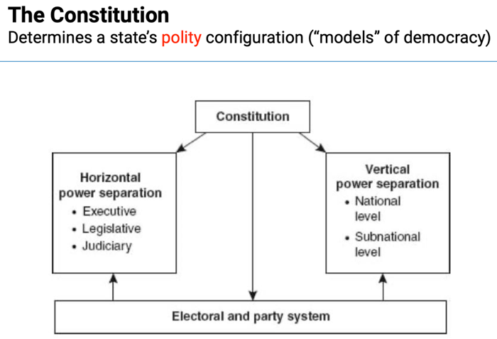
The constitution determines the horizontal division of power among the executive, legislature, and judiciary. These branches define how authority is shared and checked within a political system:
- Executive: Manages the bureaucracy and implements policy. In practice, it also proposes and formulates policies. The degree of executive power varies across systems.
- Legislature: Makes and legitimizes laws, can play a role in choosing the head of government, and may be unicameral (one chamber – single legislative body) or bicameral (‘lower’ and ‘upper house’).
- Judiciary: A hierarchical system of courts with a supreme or constitutional court in the top. It applies laws, resolves disputes, and can review constitutionality. Though formally independent, it can influence policy through rulings and interpretations.

3. Executive–Legislative Relations
Two main classifications describe how democracies distribute power and responsibility:
- Presidential vs. Parliamentary systems – who governs, how powers are separated, and where political responsibility lies.
- Majoritarian (“Westminster”) vs. pus systems – how power and participation are distributed, and how interest-group pluralism is managed.
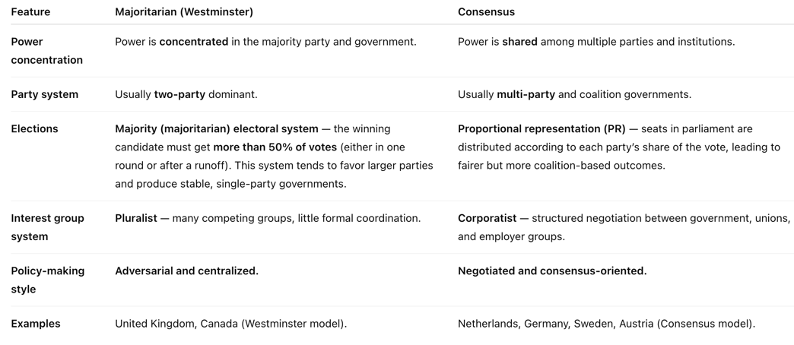
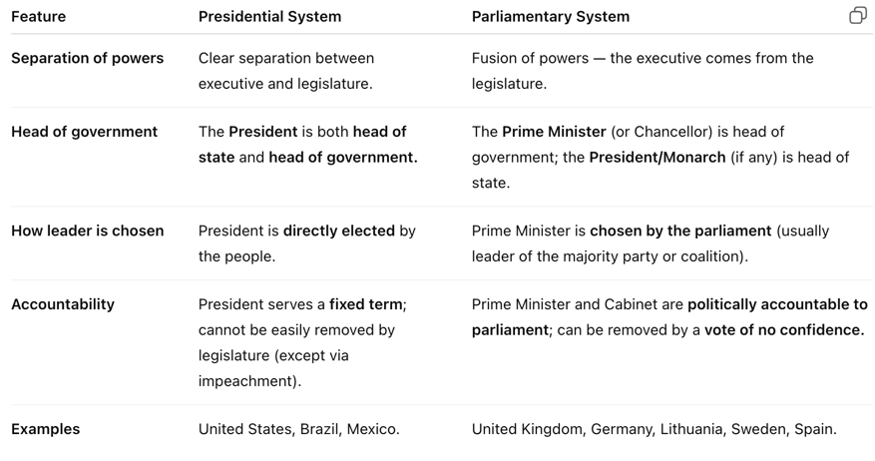

4. Westminster (Majoritarian) Model
The Westminster model concentrates power in the executive and favors quick, decisive government.

Key features:
- One-party cabinets with strong cabinet dominance.
- Two-party system and majoritarian or disproportional elections.
- Interest-group pluralism – many groups compete independently for influence.
- Unitary and centralized government, usually unicameral (UK is an exception).
- Flexible constitution, no judicial review, and low central bank independence.
(Lijphart, ch.1)

This model favors efficiency and accountability, but often limits representation and inclusiveness.

5. Consensus Model
The consensus model disperses power more widely and emphasizes negotiation and inclusion.

Key features:
- Broad coalition cabinets and balance between executive and legislature.
- Multiparty system with proportional representation (PR).
- Interest-group corporatism – organized cooperation between key groups (employers, unions).
- Federal or decentralized structure, often with strong bicameralism.
- Rigid constitution, judicial review, and independent central bank.
(Lijphart, ch.2)

Consensus systems are slower and more complex but aim for stable, representative, and negotiated policymaking.

6. Relationship Between Cabinet Type and Executive Dominance
Empirical data show that broader coalition executives correlate with lower executive dominance (r = 0.78, p < .01). This means that when the executive includes a wider range of political parties or interests, power becomes more balanced across branches, especially between the executive and the legislature.
A more diverse executive must negotiate and compromise more often, leading to more proportional and inclusive decision-making within the political system.

Lijphart’s conclusion:
“Polity shapes policy.” Consensus democracies generally outperform Westminster systems in policy effectiveness, governance quality, democratic representation, and the kindness or gentleness of policy orientation.
Their decision-making is slower and more inclusive, but not less stable.

7. The Executive as a Public Policy Actor
The executive consists of the head of government (prime minister, chancellor, or president) and the cabinet ministers. It plays a central role in the policy process, especially in policy formulation.
- Structure and principles
- Two rival principles define how cabinet ministers operate:
• Principle of collective responsibility – all ministers publicly support cabinet decisions.
• Principle of ministerial autonomy – each minister manages their own portfolio independently.
- Cabinets must be either supported (by a minimal-winning or oversized coalition) OR tolerated (as a minority government) by a parliamentary majority.
The toleration condition is less relevant in presidential systems, where the executive and legislature are separately elected.
- Role in the policy process
- The executive is crucial during policy formulation, particularly in parliamentary systems, where most policy proposals originate from the cabinet.
- It relies heavily on ministerial bureaucracies for expertise, drafting, and implementation.
- This dependence encourages close ties between government officials and private-sector or interest-group representatives, forming policy communities, iron triangles (stable alliances between bureaucrats, legislators, and interest groups), and issue networks (more fluid and open coalitions of actors – officials, experts, NGOs – collaborating on specific policy issues) that link politicians, civil servants, and organized interests.
- Through its managerial oversight of the bureaucracy, the executive exercises significant discretionary power – meaning it can influence and steer nearly all stages of the policy process.

8. The Bureaucracy as a Policy Actor

The bureaucracy enjoys a degree of “embedded autonomy” – it is part of society but operates with independence from direct political or social pressures. Its classical role is to implement (execute) public policies, but its knowledge and expertise also allow it to influence agenda-setting and policy formulation.

There are two main types of bureaucracies:
- Implementing (street-level) bureaucracy, which applies policy directly to citizens (e.g. teachers, police officers, social workers).
- Ministerial bureaucracy, which advises ministers, drafts laws, and manages the details of policy design.
The bureaucracy is often called the “engine room” of government – without it, neither the executive nor the legislature could function effectively. As Page and Jenkins (2005) note, policy-making happens “with a cast of thousands,” as (mid-ranking) bureaucrats draft proposals and maintain constant contact with experts and stakeholders.
Personal networks between bureaucrats and stakeholders, both domestic and international, are essential for shaping and coordinating policy.

This raises two major questions:
- What determines the effectiveness of bureaucracy?
- When does bureaucratic influence undermine democratic governance?

9. Weber’s Ideal Type of Rational Bureaucracy
Max Weber (1864–1920) described bureaucracy as a key marker of the modern capitalist state and the purest form of “legal-rational” legitimacy – one of three types of legitimate authority:
- Legal-rational legitimacy – rule based on formal laws and impersonal rules.
- Traditional legitimacy – based on custom and heritage.
- Charismatic legitimacy – based on personal authority and leadership.

A legal-rational bureaucracy operates through a professionalized, rule-based, and hierarchical system. According to Weber, effective bureaucracy is defined by ten principles:
- Officials are personally free and subject only to official duties.
- They operate within a fixed hierarchy.
- They have clearly defined competences.
- They are appointed by contract based on qualifications.
- They hold specialized expertise.
- They receive fixed salaries and pensions.
- Their official position is their main occupation.
- They pursue a career with promotion based on merit or seniority.
- They maintain separation between office and private interests.
- They are bound by discipline and supervision.

This model ensures efficiency, predictability, and impartiality, but can also lead to rigidity and detachment from political or public control.

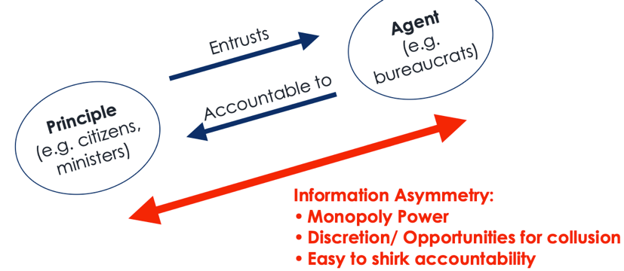
10. Bureaucratic Politics and Principal–Agent Problems
In modern governance, bureaucrats act as agents, entrusted by principals (citizens, ministers, parliaments) to implement policy.
However, information asymmetry creates tension: bureaucrats often know more than their political superiors. This can lead to:
- Monopoly power within administration,
- Discretion and opportunities for collusion,
- And shirking of accountability (bureaucrats not fully doing their job, knowing they won’t be caught).

These are known as principal–agent problems – when bureaucrats act in their own interest rather than that of elected officials or the public.
Such problems threaten both democratic legitimacy and policy innovation, as excessive bureaucratic control can hinder responsiveness and reform.

Principle-agent theory as an impulse for new managerial principles in the government-bureaucracy relationship:
– Serious economic crises in the 1970s and 1980s.
– Thatcher’s and Reagan’s neoliberal economic policies
– Collapse of the USSR.

11. New Public Management (NPM)
In response to these challenges, New Public Management emerged in the 1980s–1990s, influenced by neoliberal reforms (Thatcher, Reagan) and economic crises. It sought to make public administration more efficient by borrowing ideas from the private sector.

NPM emphasizes:
- Incentives, competition, and performance measurement instead of rigid rule-based systems (Weberian rule-based bureaucracy).
- Use of market-inspired instruments:
    - Contracting-out – governments hire private firms to deliver services instead of providing them directly.
    - Privatisation – selling state-owned enterprises or forming public–private partnerships to increase efficiency.
    - Quasi-markets – introducing competition between public agencies or service providers to improve performance.
    - Civil service reform – focusing on service quality, autonomy, and separating policy-making from implementation to make administration more flexible and results-oriented.
However, while aiming to improve efficiency, NPM often created new risks – such as corruption, fragmentation, and an increased need for regulation to maintain accountability.

12. Key Takeaways
- Public policy is best understood as a rationalist problem-solving process, typically studied through the policy cycle but also criticized by incrementalists and garbage can theorists.
- Polity (institutional structure) shapes both politics and policy outcomes, with differences between presidential vs. parliamentary and Westminster vs. consensus systems.
- Consensus democracies reflect a broader range of actors and produce more inclusive, negotiated policymaking.
- Westminster democracies often favor more centralized and adversarial policymaking styles.
- The executive’s control over the bureaucracy grants it enormous discretionary power, reinforcing its central role in every stage of the policy process.

Reading #2

A) How Institutions Shape Actors and Decision-Making

1. What institutions actually do
The chapter stresses that institutions do not only limit behavior—they also enable and guide it. They set the incentive structures that make some strategies more attractive than others.
For example, proportional-representation systems reward coalition-building, whereas first-past-the-post systems reward strategic concentration of votes. So institutions channel how rational actors pursue their goals.

2. Veto points and transaction costs
Every institutional design creates veto points—locations where policy can be blocked or amended—and shapes transaction costs, the costs of bargaining and implementation.
Systems with many veto players (federal, bicameral, coalition-based) have high transaction costs but also more stability and inclusiveness. Systems with few veto players act faster but risk volatility.

3. Policy actors beyond the “big three”
Knill & Tosun emphasize how non-state actors have become integral to policymaking:
- Interest groups provide expertise and mobilize constituencies but can suffer from the collective-action problem (Olson): larger, diffuse interests are harder to organize than narrow ones.
- Corporatist systems (e.g., Austria, Scandinavia) institutionalize cooperation between government, unions, and employer associations, while pluralist systems (e.g., US, UK) keep lobbying (attempts to persuade politicians or bureaucrats to support policies that benefit a specific group) more competitive and fragmented.
- Experts and epistemic communities influence technical policy areas (environment, health). Their authority rests on consensus within their professional field, not on electoral legitimacy.

4. International and supranational influence
A modern addition absent from your slides is international institutions as rule-makers:
- Supranational organizations (EU) can legislate directly over member states.
- Intergovernmental bodies (UN, WTO, IMF) constrain through treaties, peer review, and conditionality.
This means domestic policy often operates within nested institutions, where sovereignty is shared across levels—a point linking to vertical power divisions.

B) The Bureaucracy and Efficiency Criteria

1. Why bureaucracies vary
Knill & Tosun show that administrative traditions (Anglo-Saxon, Napoleonic, Germanic, Scandinavian) explain differences in bureaucratic autonomy, capacity, and political control.
- Anglo-Saxon: pragmatic, managerial, high turnover, less formal hierarchy.
- Continental (Napoleonic/Germanic): legalistic, career civil service, emphasis on rule of law and continuity.
- Nordic: consensus-oriented, socially embedded civil servants with high trust.
These traditions influence whether bureaucrats act mainly as neutral implementers or as policy advisors and initiators.

2. Bureaucratic effectiveness beyond Weber
Knill & Tosun operationalize bureaucratic efficiency through three criteria:
- Capacity – resources, skills, and coordination ability.
- Autonomy – insulation from political interference.
- Accountability – mechanisms ensuring responsiveness and legality.
High capacity + autonomy with strong accountability = most effective.
Too little autonomy → politicization; too much → technocracy or “rule by experts.”

3. Administrative pathologies
The reading notes that bureaucracy can fail through:
- Over-bureaucratization (red tape, rigidity).
- Capture or collusion with regulated interests.
- Fragmentation after NPM reforms (too many semi-autonomous agencies).
These illustrate the constant trade-off between efficiency, control, and democratic legitimacy.

4. Principal–agent elaboration
Beyond your slides: Knill & Tosun link this to delegation theory—politicians delegate to bureaucrats because it saves time and provides expertise, but they must design monitoring mechanisms (audits, performance contracts, reporting).
NPM’s “contracting logic” is one such attempt, though it can increase transaction costs if monitoring outweighs gains.

C) Horizontal and Vertical Divisions of Power

1. Horizontal separation (executive–legislative–judicial)
Knill & Tosun detail how checks and balances are realized differently:
- Presidentialism: strict separation; executive has fixed mandate; risk of deadlock.
- Parliamentarism: fused powers; executive dependent on legislative confidence; risk of executive dominance when majorities are disciplined.
- Judicialization of politics: in both types, courts have expanded influence through constitutional review, often becoming policy-shapers themselves (e.g., environmental, social rights rulings).

2. Bicameralism
Not just about two chambers—the key question is symmetry and congruence:
- Symmetrical bicameralism (e.g., US, Italy) gives both chambers near-equal power → more negotiation.
- Asymmetrical (e.g., UK House of Lords) limits the upper chamber to review/delay powers.
This design affects legislative speed and the number of veto players.

3. Vertical division: federalism and decentralization
Knill & Tosun go further than the slides by typologizing federal designs:
- Dual/coordinated federalism (U.S.): clear separation of competences.
- Cooperative federalism (Germany): intertwined responsibilities and joint decision-making.
- Decentralized unitary states (UK, Spain): formal unitary structure but significant self-rule.
They emphasize that federalism is not static—many states experience “creeping centralization” or “re-regionalization.”

4. Multi-level governance
The authors extend the vertical dimension to supranational and subnational levels:
Policy is now made in interlocking arenas (EU, national, regional, local). Authority is shared and negotiated rather than hierarchical. This blurs accountability but allows policy innovation and cross-level learning.

D) Key Insights the Slides Didn’t Cover
- Institutions are not neutral: they favor certain actors, values, and time horizons (e.g., federalism protects minorities; majoritarianism rewards speed).
- Administrative traditions and path dependency explain why reforms (like NPM) have different results across countries.
- Efficiency in the public sector is multidimensional: it requires balancing capacity, autonomy, accountability, not just cutting costs.
- Judicial and international actors now function as fourth and fifth branches of policymaking.
- Federal and multi-level systems expand participation but multiply veto points, requiring negotiation and coordination rather than command.

Lecture 3 – State-Society Relations

1. Key Non-State Actors
Beyond formal state institutions, policymaking involves several influential non-state actors – political parties, interest groups, and experts – who connect citizens and organized interests to the political system. They shape both how preferences are expressed and how policies are formulated.

2. Political Parties
A political party is an organization that seeks influence in the state by competing for government positions and aggregating interests across society (Ware, 1996).

Main Functions:
- Coordinating preferences: Parties link citizens’ beliefs and interests with candidates and elected officials, transforming public opinion into political agendas.
- Structuring electoral competition: They recruit personnel, formulate policy programs, and organize campaigns to influence voters.
- Representing citizens: Party representatives act as delegates or trustees, giving citizens voice in policymaking.
- Legitimizing the system: By participating in elections, parties sustain trust in democratic institutions – although the rise of populist and challenger parties has complicated this function.

3. Classifying Political Parties
Parties are usually classified by ideology along two dimensions:
a) Economic (left/right): left parties favor redistribution and public welfare, right parties emphasize market freedom and limited state intervention.
b) Social (liberal/conservative): liberals support progressive values and individual freedoms, conservatives favor tradition and authority.
The Global Party Survey (2019) also measures populism, showing variation in how parties appeal to “the people” against “the elite.”

4. Party System Characteristics
Political systems differ not only by party ideology but by how stable or fragmented they are.

- Electoral Volatility: Refers to the net change in party vote shares between elections. High volatility means shifting voter loyalties and weaker party identification (e.g. Latvia, Lithuania, Turkey). (“the net change within the electoral party system resulting from individual vote transfers”)
- Fragmentation: Measures how many parties gain significant representation in a system. More fragmentation usually leads to coalition governments and slower decision-making. (“how many parties, weighted according to size, are in a party system in a given election”)
- Polarisation: Captures the vote share of anti-establishment parties – the extent to which “outsider” or protest parties challenge mainstream politics. High polarisation signals deep ideological divisions and growing dissatisfaction with established elites. (“the percentage of votes obtained by “anti-political-establishment” parties”)

5. Interest Groups
Interest groups (also called advocacy groups, NGOs, or lobby groups) are private organizations that make policy suggestions to public actors – governments, parliaments, and bureaucracies – to align policies with the beliefs and interests of their members.

Main functions:
- Overcoming collective-action problems: Groups help coordinate people with shared preferences, though large groups face free-rider problems when benefits are diffuse.
- Influencing policymaking: They provide specialist knowledge, campaign resources, or financial support to shape legislation.
- Inside lobbying: Direct cooperation with officials within policymaking arenas (e.g., participation in iron triangles).
- Outside lobbying: Public campaigns and media advocacy aimed at shaping opinion from outside formal policymaking channels.

6. Interest Groups vs. Social Movements
While both seek to influence politics, social movements differ by being less institutionalized and more confrontational:
- They adopt a conflictual orientation toward opposing groups.
- They emphasize a collective identity (e.g. climate or feminist movements).
- Their actions are unconventional – protests, strikes, demonstrations – rather than formal lobbying.
- They generally reject routine cooperation with official institutions.

7. Conditions for Policy Influence of Interest Groups
Several factors determine how much influence an interest group can exert:
- Internal organization: Financial resources and leadership capacity affect lobbying strength.
- Complexity of the issue: Technical or specialized policies increase reliance on expert groups.
- Competition between groups: The level of rivalry and access to policymakers depends on the institutional context:
- Interest Group Pluralism: A "marketplace" of interest groups, where many groups compete for influence over policy. Multiple interest groups can access policymakers, but influence is more fragmented because groups compete against one another. This model is common in systems like the United States, where many interest groups are competing independently for policymakers' attention.
    - Interest Group Corporatism: Fewer, more institutionalized ties between the state and key associations; regular tripartite bargaining among government, employers, and unions; centralized wage negotiation and high unionization.

8. Experts
Experts are individuals or networks with specialised, policy-relevant knowledge in specific issue areas, typically based on scientific credentials (academic or industry). They form part of epistemic communities – transnational networks of professionals who share common causal beliefs and policy goals (e.g., the IPCC, or expert panels during Covid-19).

Main functions:
- Providing causal connections: Experts help policymakers understand how specific causes lead to certain policy outcomes, offering ideas for action.
- Providing impartial evidence: They supply data and analysis to guide decisions, though full neutrality is difficult as science operates within social and political contexts.
- Brokering between coalitions: Experts can mediate between coalitions with competing belief systems, helping to build consensus in contested areas.

9. Evidence-Based Policymaking (EBPM)
EBPM represents the “gold standard” of modern public policy, where decisions are ideally grounded in empirical evidence rather than ideology or political expediency (*covid-19)
- It expanded with New Public Management (NPM) reforms in the 1990s, emphasizing efficiency, accountability, and measurable outcomes.
- International organizations like the OECD, World Bank, and EU Commission promote evidence-driven policymaking.

Limitations:
- Evidence is always interpreted and processed by humans – it can be selectively used (“cherry-picked”) to fit political goals.
- There is a danger of policy-based evidence-making, where governments manipulate data to justify pre-decided policies.
- The process risks politicizing science, as seen during Covid-19 debates about public health measures.

10. Think Tanks
Think tanks are hybrid institutions at the intersection of research, advocacy, and policymaking – acting as major players in the “marketplace of ideas.”

Key characteristics:
- They produce policy analysis and recommendations, influencing how ideas spread and become embedded in political discourse.
- Combine objective research with activism, blurring lines between academia and politics.
- Especially influential in the United States, where ideological diversity among think tanks (e.g. Cato Institute, RAND Corporation, Friedrich Ebert Stiftung) reflects broader partisan divides.
- Scholars and policymakers must remain aware of their programmatic or partisan origins, as think tanks often pursue agendas aligned with specific political or economic interests.

11. Modelling State–Society Relations: The Advocacy Coalition Framework (ACF)
Developed in the early 1980s by Paul Sabatier and Hank Jenkins-Smith, the ACF explains how policy change happens over time through the interaction of coalitions of actors that share common beliefs within a specific policy subsystem.

12. Main Aspects of the ACF Model
- Focuses on the policy subsystem – the network of actors and institutions concerned with a specific policy issue (e.g. energy policy, education, or environmental regulation).
- The unit of analysis is the actor network within a sub-system rather than isolated institutions.
- Actors’ belief systems (values, goals, perceptions) are central to understanding their behavior.
- The ACF aims to produce testable predictions about when and how policies change – or remain stable.

13. The Policy Subsystem
A policy subsystem is the arena where advocacy coalitions interact, negotiate, and compete.

Key characteristics:
- Issue-centric: Groups organize around a specific policy problem, not around entire sectors.
- Brokered cooperation: Coordination is often mediated by insiders (policy brokers – they are neutral & have a desire to “move forward” => try to bring coalitions together).
- Geographic dimension: Subsystems often form around particular countries or regions.
- Institutional embeddedness: Subsystems operate within formal political and administrative frameworks.
- Responsive to external shocks: Elections, crises, or regime shifts can reshape subsystem dynamics.

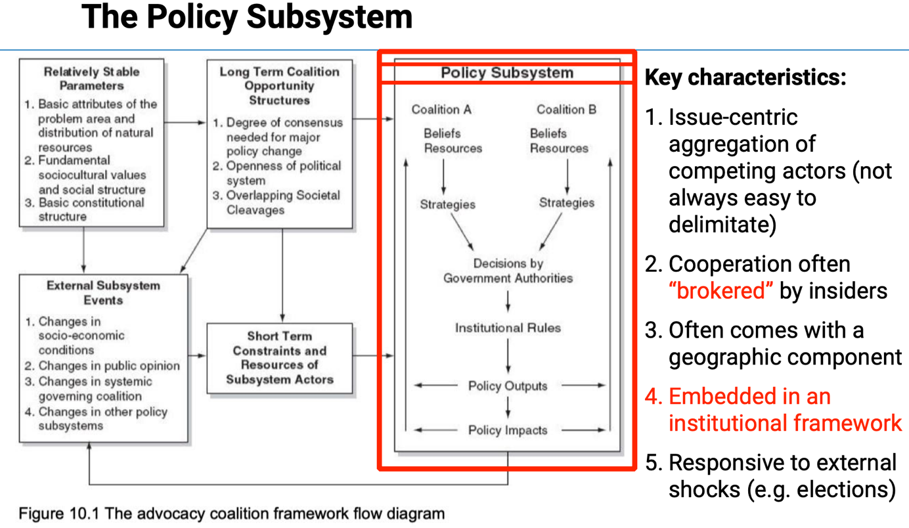

Beliefs < > Interests: Beliefs are deeper and form the foundation of preferences, while interests are the practical goals derived from those beliefs.

14. Coalitions and Their Belief Systems
- Policy actors (both formal and informal) form coalitions based on shared beliefs and values.
- Each coalition tries to translate its belief system into concrete policy outputs.
- Therefore, a given public policy reflects the belief system of the coalition that has succeeded in dominating the subsystem.
“A given public policy is best understood as the translation of some belief systems, namely those that have ended up being successful.”

14a. Mapping and Identifying Coalitions
Inferring Coalition Boundaries:
Network analysis helps reveal how actors cluster based on shared beliefs or cooperation.
- Modular networks = coalitions exist but still interact.
- Modular + segregated networks = clear, polarized coalitions with little cross-communication.
→ Shows how cohesive or conflictual a policy subsystem is.

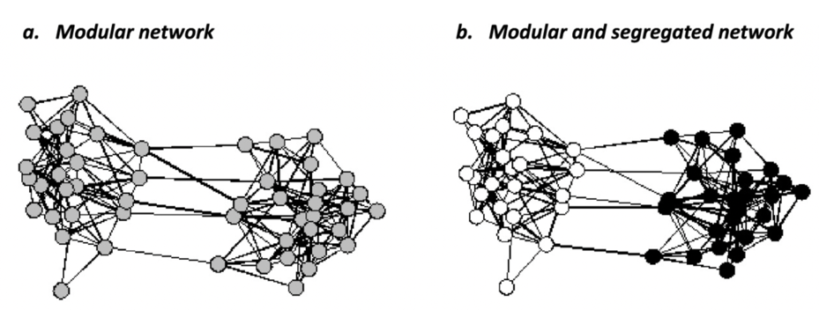

Example – U.S. Climate Policy Subsystem:
Three main coalitions:
- Environment (green): sustainability and regulation.
- Economy (red): growth and deregulation.
- Science (blue): evidence-based policy.
Democrats align with environment/science, Republicans with economy → illustrates belief-driven alliances among diverse actors.

15. Three Levels of a Policy Belief System
- Deep Core Beliefs
  - Fundamental, ideological convictions (e.g. about human nature, justice, the role of government, left–right divide).
  - Very resistant to change.
- Policy Core Beliefs
  - Application of these deep values to specific policy domains (e.g. “government should regulate the energy market”).
  - Change occurs only through major political shifts.
- Secondary Aspects
  - Technical or instrumental beliefs (e.g. choice of tools, regulatory details).
  - Easier to adapt and modify.

The likelihood of policy change increases as one moves from deep core to secondary aspects.

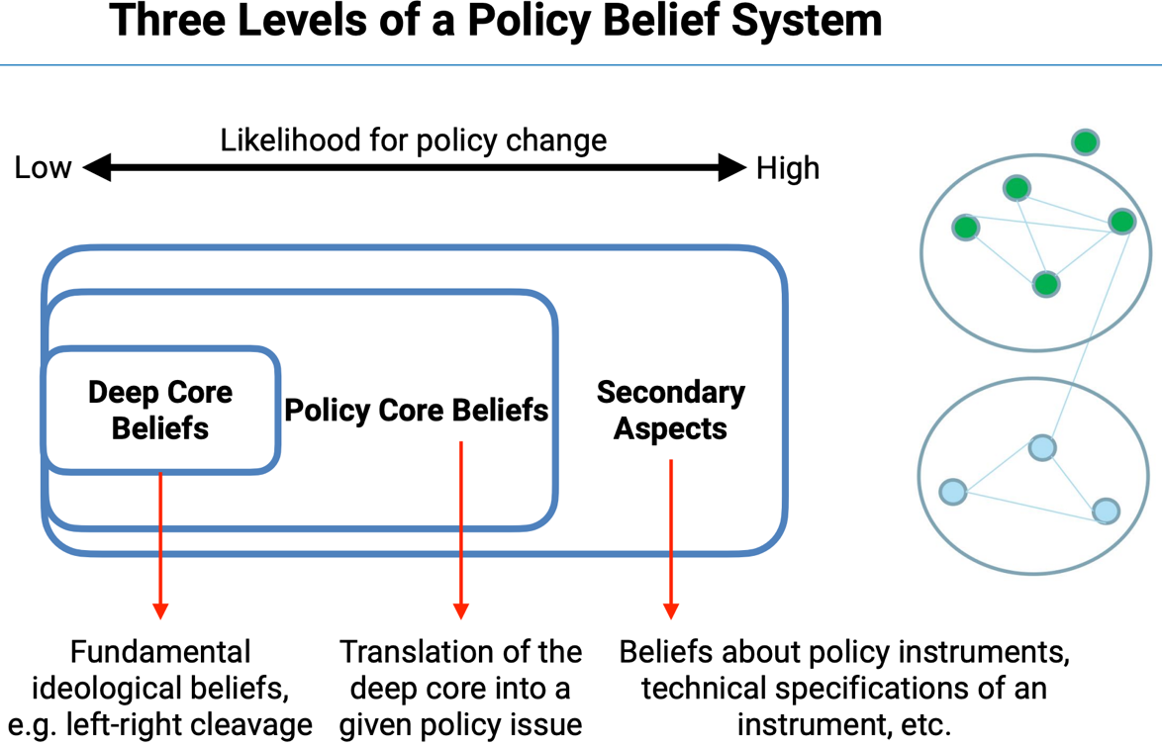

16. “Major” and “Minor” Policy Change
Policies evolve when coalitions change – either in composition or in belief systems.
- Major policy change: Occurs when core beliefs of dominant coalitions shift (e.g. welfare state reform, environmental paradigm shift).
- Minor policy change: Involves adjustments to secondary aspects (e.g. emission limits, technical procedures).

17. Reasons for Policy Change
Policy change within the ACF can result from both external and internal factors affecting coalitions and their belief systems.
- External shocks can trigger major policy change by altering the policy core beliefs of dominant coalitions. These include:
  - Socio-economic changes (e.g. recessions, technological transformation)
  - Regime changes (e.g. elections or revolutions)
  - Disasters or crises (e.g. pandemics, nuclear accidents)
  - Spillover effects from other policy subsystems
- Internal shocks usually lead to minor policy change, involving adjustments in secondary aspects. These arise from:
  - Crises within a coalition (loss of credibility or leadership)
  - Policy learning, which can occur:
    - Within coalitions – adapting policies in light of new evidence or experience (e.g. on soft drugs)
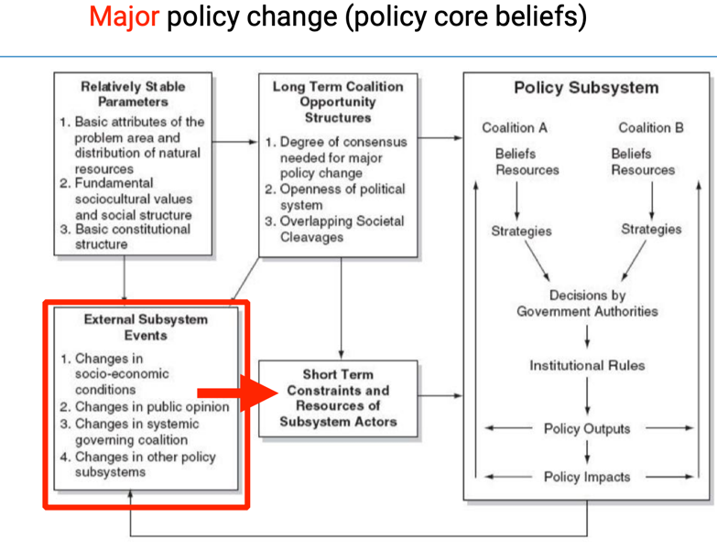
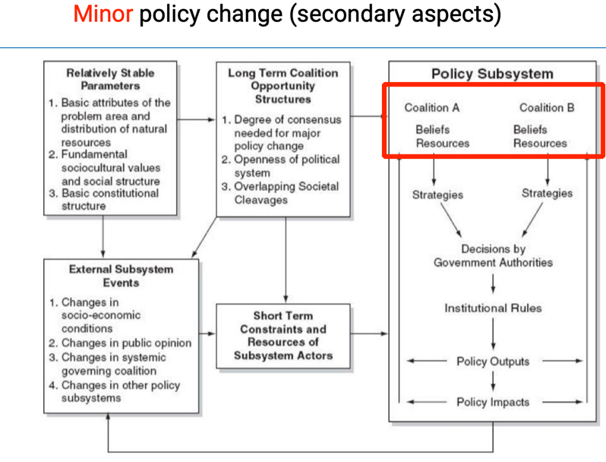
    - Across coalitions – through policy brokers mediating between opposing groups and facilitating compromise

19. Reasons for Policy Stability – The ‘Devil Shift’
Sabatier, Hunter, and McLaughlin (1987) describe the Devil Shift – when advocacy coalitions tend to see opposing coalitions as more “evil” and more powerful than they really are.
This happens because actors rely on:
- Heuristics – mental shortcuts to fill in missing information.
- Confirmation bias – focusing on information that supports existing beliefs.
- Loss aversion – fearing losses more than valuing potential gains.

The Devil Shift leads to conflict escalation and entrenched beliefs, making policy change less likely.
Policy brokers play a key role in reducing these tensions and encouraging cooperation between rival coalitions.

19. Key Upshots
- The executive’s control of bureaucracy grants enormous discretionary power but also raises principal–agent problems.
- Bureaucracies, while expert-driven, can be self-interested and politicized.
- New Public Management (NPM) sought to address inefficiency by introducing market-like incentives and accountability mechanisms.
- Clear distinction must be made between political parties, interest groups, and epistemic (expert) communities.
- Institutional arrangements (e.g. executive-legislative balance, electoral systems) shape political dynamics and thus policy outcomes.
- The Advocacy Coalition Framework integrates institutions and actors to explain how state–society relations evolve, offering a powerful model to analyze major and minor policy change.

Reading #3

1. From Government to Governance
The reading reinforces the shift from government (centralized, hierarchical decision-making) to governance, which emphasizes networks of interdependent actors — public agencies, interest groups, NGOs, and experts — working collaboratively and competitively across institutional boundaries.
This change implies that policymaking is polycentric — authority and influence are distributed, not concentrated, and successful policy depends on coordination across multiple centers of power.
Governance is therefore seen as a process of negotiation and learning rather than command and control.

2. A Broader Conception of Policy Actors
While the lecture emphasized parties, interest groups, and experts, the reading adds new distinctions:
- Policy entrepreneurs – individual leaders who invest resources to promote innovative ideas and strategically link coalitions.
- Policy brokers – mediators who seek compromise between rival coalitions to maintain subsystem stability.
- Auxiliary actors – peripheral participants who occasionally align with a coalition when interests overlap.
- Latent actors – those indirectly affected by policies but not yet mobilized.
This layered typology helps identify not just who acts, but how consistently and with what strategic purpose.

3. The Role of Beliefs in Coalition Behavior
The lecture noted that beliefs are the “glue” of coalitions, but the reading deepens this concept by showing how beliefs shape cognition and perception:
- Beliefs guide information processing – actors interpret data selectively through their ideological lenses (“bounded rationality”).
- Beliefs define policy problems – they determine what counts as a problem and which solutions seem legitimate.
- Beliefs create stability – they explain why coalitions persist despite new evidence or political turnover.
This underlines that policymaking is as much about contested meaning as about technical problem-solving.

4. Policy Subsystems as Arenas of Continuous Interaction
Weible & Ingold highlight that subsystems are not static — they are evolving ecosystems where actors learn, compete, and adapt.
Subsystems can differ by:
- Issue scope (e.g. energy, climate, education),
- Geographic scale (local, national, international), and
- Temporal dynamics (some stable for decades, others volatile).
This reinforces the idea that policy change is gradual — it happens through continuous interaction and accumulated learning, not only crises or external shocks.

5. Coordination Patterns: Strong vs. Weak Coalitions
The reading introduces the distinction between strong and weak coordination:
- Strong coordination – actors deliberately align strategies, share resources, and coordinate lobbying.
- Weak coordination – actors act independently but in ways that complement each other due to shared beliefs.
This nuance shows that coalition unity doesn’t always require formal organization — shared ideas can substitute for formal structure.

6. Identifying Power and Influence
The chapter provides four analytical approaches to study influence within a subsystem — a clear methodological addition to the lecture:
- Positional – who holds official authority.
- Decisional – who actually participates in shaping policy outcomes.
- Reputational – who is perceived as influential by others.
- Latent – who could become active given sufficient motivation or threat.
Together, these reveal how power in governance extends beyond visible, institutional control.

7. Mechanisms of Policy Change
While the lecture discussed major (external) and minor (internal) policy change, the reading emphasizes mechanisms behind these transitions:
- Threat perception as a mobilizing force — coalitions often form in reaction to perceived threats to their beliefs.
- Inter-coalitional learning — gradual convergence through information exchange and socialization.
- Strategic framing — actors reframe problems to make their beliefs more acceptable to broader audiences.
These mechanisms illustrate that change results from both cognitive adaptation and strategic interaction.

8. Practical and Normative Insights
The reading concludes with several practical lessons:
- Coalitions democratize policymaking by opening participation beyond elected officials.
- But they also risk fragmentation and opacity, as informal influence can obscure accountability.
- Effective governance requires balancing inclusiveness with coherence — ensuring diverse voices contribute without paralyzing decision-making.
In essence, the ACF shows that the policy process is both political and cognitive: it depends on who believes what, and how those beliefs shape cooperation, conflict, and learning.

Lecture 4 – Multi-Level Governance

1. What is Multi-Level Governance (MLG)?
- Definition: Describes the dispersion of political power across different jurisdictions and actors, both within and beyond national states.
- Emerged after WWII, as globalization and European integration deepened.
- Governance vs. Government:
  - “Government” implies top-down control.
  - “Governance” highlights shared, negotiated authority dispersed between formal (states, institutions) and informal (NGOs, networks) actors.
  - Governments should “steer, not row” – coordinate rather than dominate policy processes.
- The EU is the clearest example: combines supranational scaling-up (EU institutions) with domestic decentralization within states (subsidiarity principle).
‘Multi-level governance’: describes the dispersion of power within and beyond central (national) states.

2. Two Logics Behind MLG
- Choice logic:
  - Governance reflects a desire for self-rule – autonomy based on regional identity, language, or culture.
  - Governance should reflect local histories and social realities.
  - Leads to differentiated governance (e.g. special rights or autonomy for minority regions).
- Necessity logic:
  - Governance as a tool for the efficient delivery of public goods.
  - Assumption of “optimal spatial scales” for managing issues – local problems locally, transnational problems globally.
  - Linked to the “governance ladder” – the idea that larger populations require more tiers of authority for effective coordination. (“linear relationship between government levels and population size”)

3. The Governance Ladder
- Visualizes the hierarchical but rational structure of MLG.
- Each “rung” (local, regional, national, supranational) corresponds to a population scale.
- The larger the population, the greater the benefit of having multiple levels of government to manage complexity.
- Example: municipalities → regions → states → international organizations.
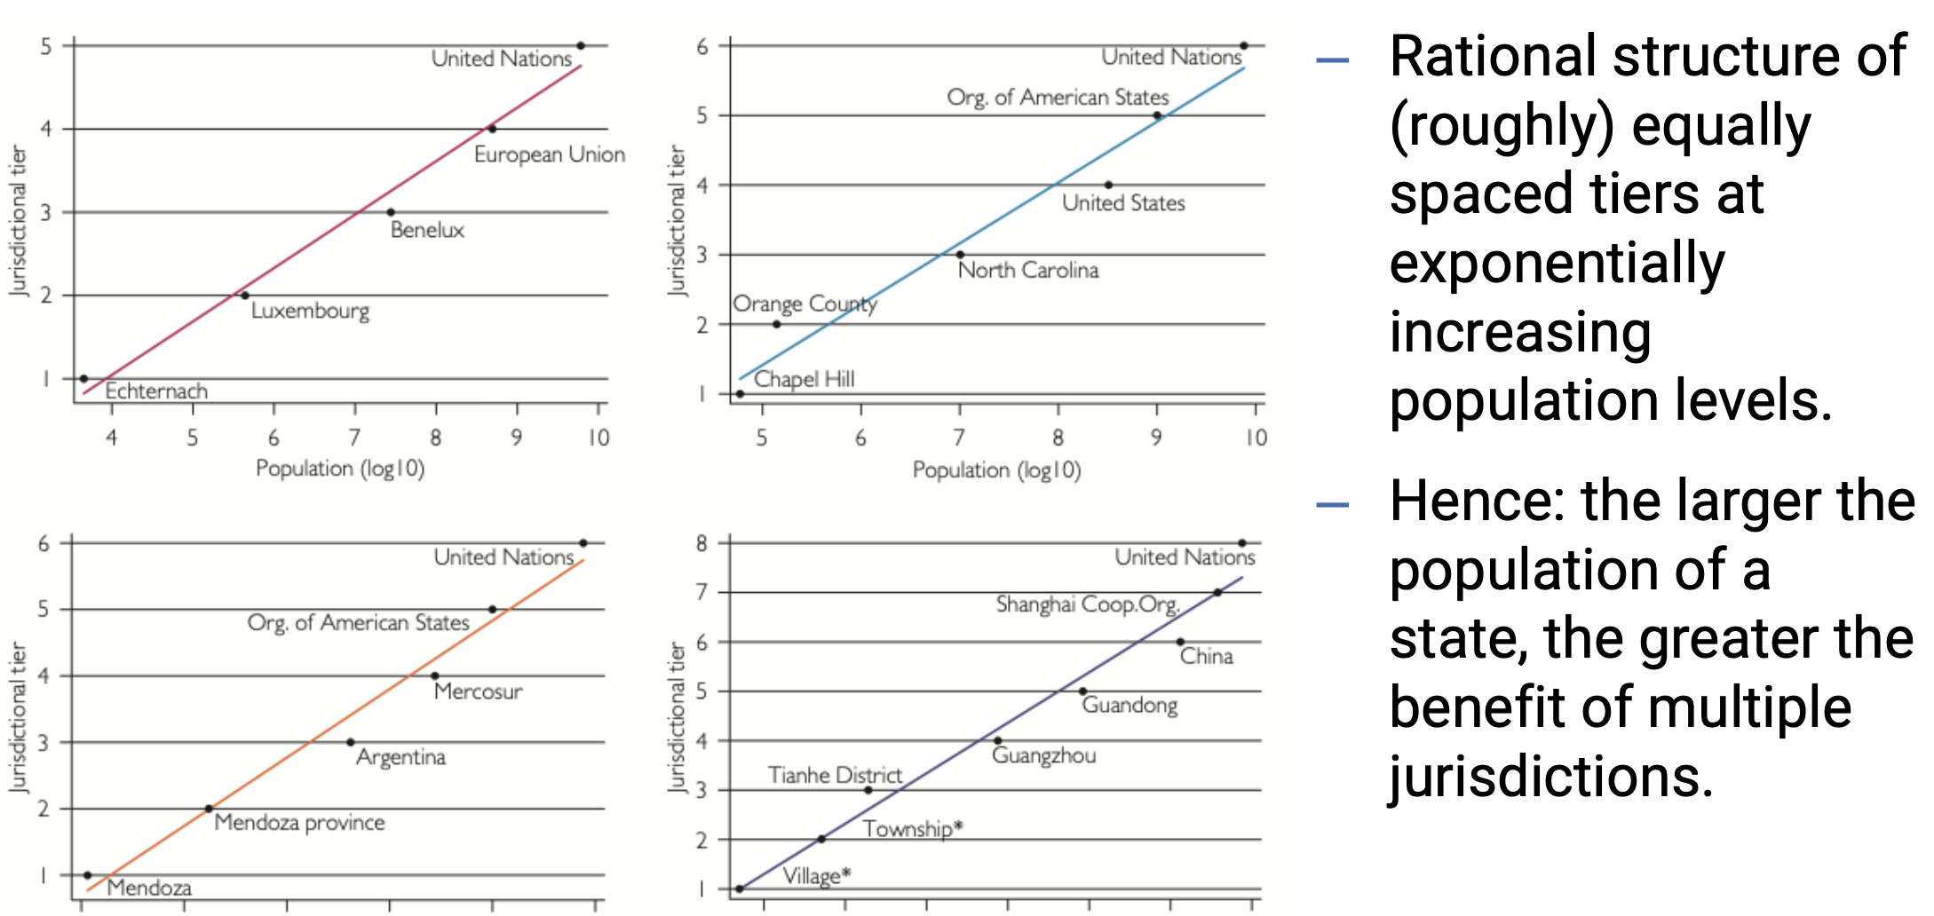

4. MLG and the Federal–Unitary Dimension
The federal–unitary distinction describes how authority is distributed vertically within a state, but MLG shows that in practice these forms often overlap.
- Unitary systems (e.g. UK, Denmark, France, Latvia):
  - Power is concentrated at the center.
  - Subnational authorities exist but operate under the control of the national government.
  - The central authority can change the vertical division of power unilaterally.
  - Some unitary systems include devolved regions with substantial autonomy (e.g. Scotland, Catalonia) (“quasi-state”), but their powers remain revocable.
- Federal systems (e.g. U.S., Germany, Switzerland, Brazil):
  - Power is constitutionally divided between central and subnational governments.
  - Each level has its own sphere of sovereignty (“dual sovereignty”).
  - Neither level can unilaterally alter the other’s authority.
  - Federalism aims to balance self-rule (autonomy for subnational units) and shared rule (joint participation in federal institutions).
- Rather than a binary, the federal–unitary dimension forms a continuum.
  - Some unitary systems are highly decentralized, while some federations function with strong centralization.
  - MLG captures this variation, emphasizing how power is shared, negotiated, and coordinated across levels rather than fixed in law alone.

5. Variation and Growth of Local Authority
Across Europe, there is little variation in overall local and regional authority, but countries differ in how power is distributed between these levels.

- Federal countries (Germany, Switzerland, Belgium) emphasize strong regional authority, while Nordic states rely on local autonomy.
- Southern and Eastern Europe remain more centralized, though gradual decentralization continues.

Globally, since 1950, there has been a trend toward deepening regional authority – driven by both functional needs (managing complexity) and political pressures (identity, democratization)

6. Main Drivers of Multi-Level Governance
MLG grows due to several forces:
- Ethno-territorial identity:
- Regional communities demand self-rule to protect culture and autonomy.
- Successful cases create spill-over effects, motivating other regions.

- Democratization:
- Expanding democracy increases local accountability and participation.
- Citizens organize more easily and demand a voice in governance.

- Interdependence:
- States are too small for global challenges but too large for local issues.
- MLG balances these pressures through cooperation across levels.

- Higher living standards:
- Wealthier societies can sustain more complex governance structures.
- Citizens expect tailored, multi-level decision-making and better service delivery.

7. Challenges to Multi-Level Governance
MLG brings flexibility but also new problems of governance:
- Institutional obstacles: Westminster-style systems favor centralized control, which conflicts with MLG’s diffused authority (e.g. Brexit’s “Take Back Control”).
- Blurred responsibilities: unclear accountability enables blame shifting and may foster corruption in weak institutions.
- Voters may have a hard time to hold decision-makers accountable.
- Politicians may have strategic incentives to blur responsibilities (or claim credit for good outcomes).
- Dispersing power away from the center may increase corrupt opportunities (see e.g. Argentina, Brazil).
- Coordination problems: overlapping competences between levels cause inefficiency and policy inconsistency (e.g. differing COVID-19 regulations).
- Politicization of interdependence:
  - Global networks become instruments of power – states use them strategically (weaponization of interdependence).
  - Panopticon effect: interdependence used for surveillance and control (e.g. U.S. access to SWIFT data).
  - Chokepoint effect: exclusion from key systems as a form of pressure (e.g. Russia cut off from SWIFT after 2022).

8. Key Takeaways
- MLG explains how political authority is distributed and coordinated across multiple levels.
- Federalism and unitarism are ends of a continuum, not opposites.
- The EU exemplifies MLG, combining supranational integration with regional and local autonomy.
- While MLG improves flexibility and inclusion, it creates coordination, accountability, and politicization challenges.

Reading #4

1. Concept of Multi-Level Governance (MLG)
MLG describes the dispersion of power from national governments to other levels — supranational, regional, and local — as well as to non-governmental actors. It blurs the boundary between formal authority (laws, institutions) and informal influence (networks, interest groups).
- Choice: deliberate power-sharing (e.g. federal constitutions, EU devolution).
- Necessity: limits of central capacity — lack of attention, resources, or control.
→ MLG reflects both governance by design and governance by constraint.

2. From Westminster Model to Governance
The Westminster Model (WM) assumes centralized control, strong executives, and clear accountability.
MLG, in contrast, shows policymaking as fragmented, negotiated, and interdependent.
- WM: hierarchy and command.
- MLG: cooperation and shared authority.
This shift recognizes that governments can influence more than they can control.

3. Governance: Interdependence and Limited Control
Governance highlights mutual dependence between public and private actors.
Governments have authority but lack the capacity to implement alone. They rely on policy networks—exchanges of information, resources, and influence.
This creates self-organizing systems, where policymaking emerges through negotiation rather than command, often leading to clientelism (mutual dependency).

4. Global Governance
Issues like climate change, migration, or pandemics require cooperation beyond the nation-state.
Global governance refers to collective management of transnational problems by states, international organizations, and civil society.
This produces regime complexity—overlapping institutions and treaties that make coordination difficult but essential.

5. New Public Management (NPM) and State Reform
NPM introduced private-sector methods into the public sector to increase efficiency:
- Contracting out services.
- Privatization and public-private partnerships (PPPs).
- Quasi-markets within government.
- Civil service reforms emphasizing performance and flexibility.
Result: a more fragmented regulatory state, where control is shared and less hierarchical.

6. Hollowing Out vs. Metagovernance
Some argue MLG led to the hollowing out of the state — loss of power to agencies, NGOs, and supranational bodies.
Others see metagovernance — governments steering indirectly by setting frameworks, incentives, and rules.
→ Central authority is not lost but transformed: it now shapes the “rules of the game” rather than issuing direct commands.

7. The EU as a Case of MLG
The European Union exemplifies MLG: authority is shared among EU, national, and regional levels.
Two perspectives explain it only partly:
- Neofunctionalism: cooperation in one area leads to spill-overs.
- Intergovernmentalism: member states retain main control.
MLG integrates both—recognizing shared, negotiated power across levels and actors.
Types of MLG:
- Type 1: few, stable, clearly defined levels (like federal systems).
- Type 2: many, overlapping, flexible jurisdictions — task-specific (e.g. EU agencies).

8. Normative Dimensions – Is MLG Better?
Empirically, MLG describes how things work; normatively, it asks how they should.
Benefits: more participation, innovation, and adaptation to local needs.
Critiques: unclear accountability and unequal influence (especially unelected bodies).
Thus, MLG’s value depends on whether power diffusion enhances democracy or reduces transparency.

9. MLG, Federalism, and Comparative Insights
Federalism and MLG both involve shared sovereignty and negotiation across levels.
- Federalism: formal, constitutional division of powers.
- MLG: informal, networked, and dynamic.
Even unitary states can act “federally” through devolution.
The EU stands between both models — a multi-level polity rather than a pure federation.

10. Theoretical Connections
MLG connects with major policy theories explaining complex policymaking:
- Punctuated Equilibrium Theory (PET): attention shifts create sudden changes.
- Multiple Streams Approach (MSA): actors couple problems and solutions when policy “windows” open.
- Polycentric Governance: multiple, interacting centers of decision-making.
All highlight bounded rationality — no single actor has full control or perfect information.
Lecture 5 – Efficiency
1. The Concept of Efficiency in Public Policy
Efficiency refers to using the least amount of input to achieve the highest possible output. In public policy, it serves as a key benchmark for assessing how limited resources can produce the greatest social benefits.
- Efficiency ≠ Effectiveness: Efficiency is about doing things right (“least amount of input to get the most amount of output”), while effectiveness is doing the right things(“whether works in general”).
- The central question: Efficient at what?
  - Economic efficiency: maximizing social welfare or total surplus.
  - Medical efficiency: maximizing the number of lives saved or health gains (QALYs).
In policy terms, the preferred action is the one that contributes most to the maximization of social welfare.

2. Allocating Scarce Resources – The Healthcare Example
In situations of resource scarcity, efficiency becomes a moral and practical challenge.
For instance, when a doctor has limited doses of life-saving medication for patients with varying needs, the policy dilemma arises: how to allocate resources to maximize benefits.
→ This introduces efficiency as a normative principle: deciding not only what can be done, but what should be done to achieve the greatest welfare.
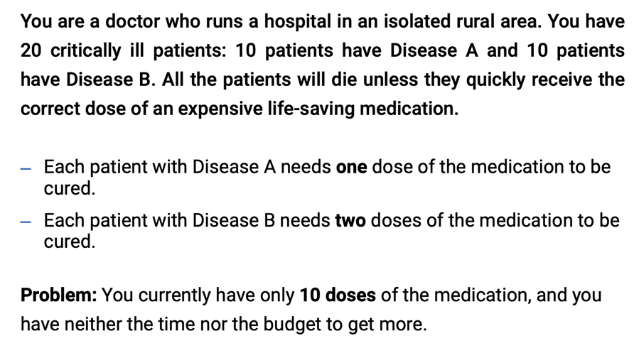
3. Utilitarian Roots of the Efficiency Principle
The modern idea of efficiency in policy is deeply rooted in Utilitarianism (Jeremy Bentham).
Utilitarianism holds that the best policy is the one that produces the “greatest good for the greatest number.”
This translates into the maximization of total social happiness or welfare, regardless of how benefits are distributed.
→ Efficiency, therefore, reflects a consequentialist logic — judging policies by outcomes, not intentions.

4. Private Choice and Utility Maximization
In economics, individuals aim to maximize their utility (satisfaction) within constraints such as income or prices.

- The optimal choice occurs where the marginal rate of substitution (MRS) equals the price ratio (i.e., where the consumer’s willingness to trade between goods matches market trade-offs).

- Preference axioms:
  - Preferences are complete (people can compare all options).
  - Preferences are transitive (consistent choices).
  - More is better than less (non-satiation).
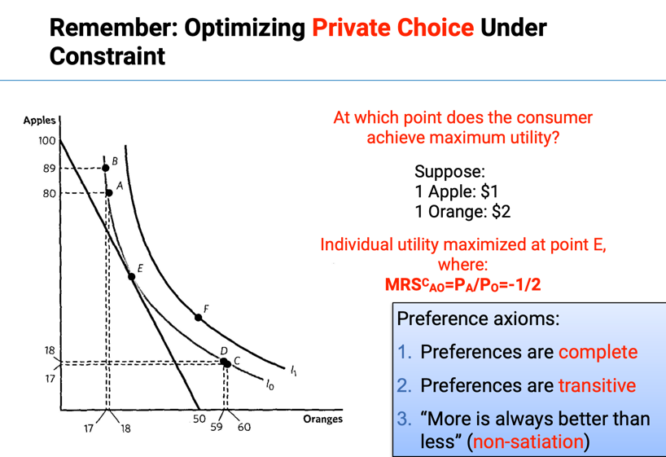

5. Scaling Up: From Private Choice to Social Choice
Policymaking mirrors the logic of individual optimization but applies it to society as a whole.
Governments must decide how to allocate resources (e.g., health budgets, education funding) to maximize social utility under constraint.
- The Utility Possibility Frontier (UPF) represents the trade-offs between different individuals’ or groups’ welfare.
- The Social Indifference Curve (SIC) shows combinations of outcomes yielding equal overall social welfare.
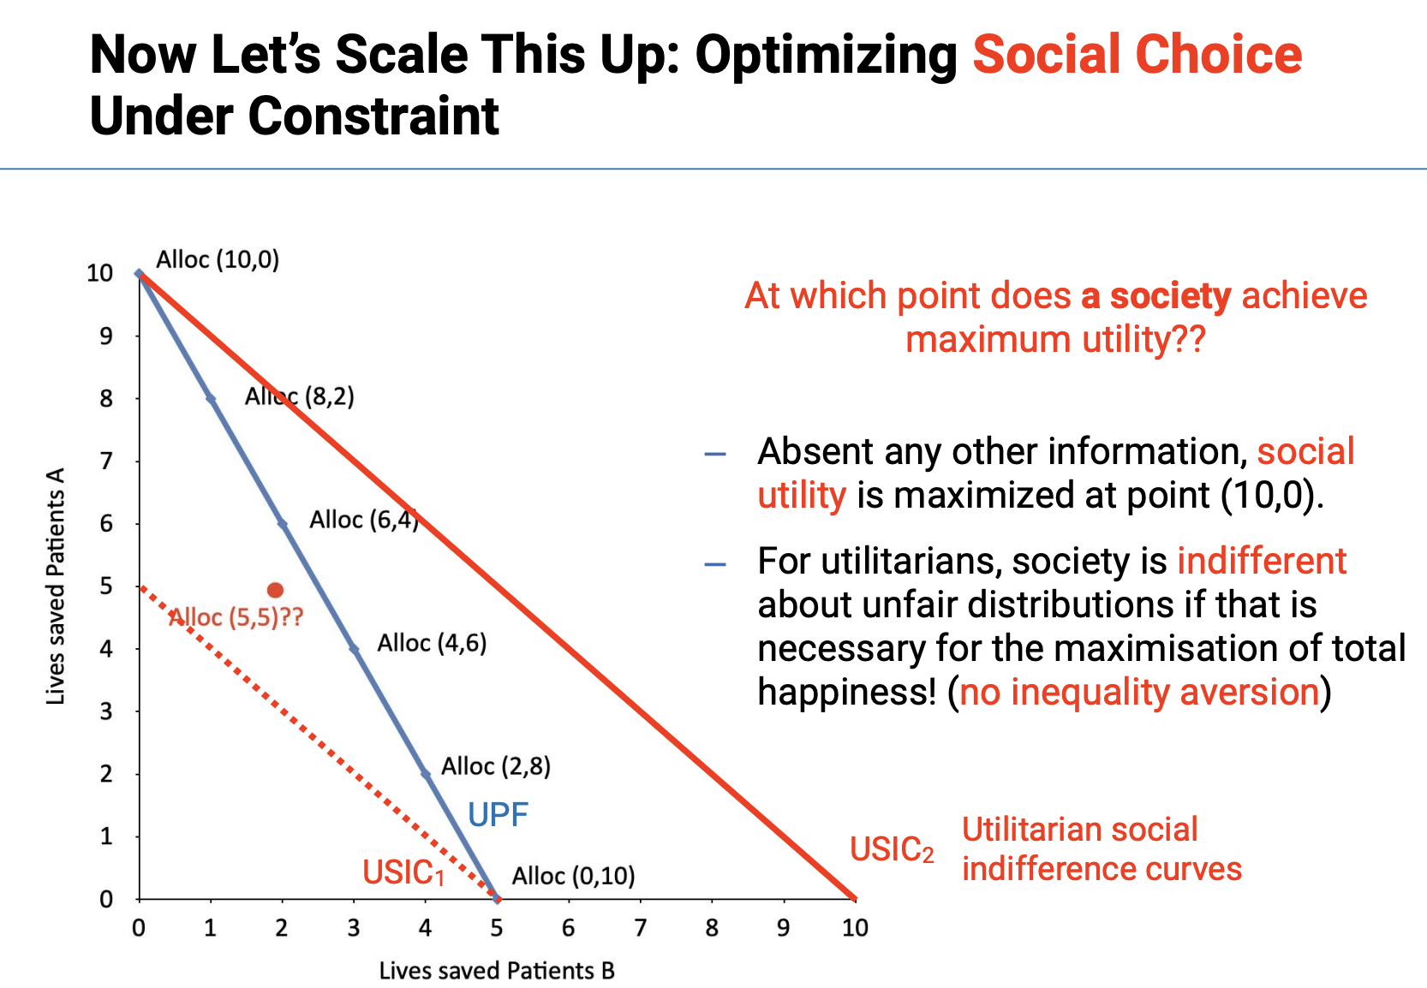
6. The Utilitarian Optimum
At the utilitarian optimum, an allocation of goods is efficient if it is impossible to reallocate the goods so as to increase the total sum of happiness in society.
Formally, the social welfare function adds up individual utilities:
→ Efficiency is achieved when total social happiness is maximized.

Key policy implication:
The right policy is the one that produces the maximum sum of welfare, even if that means unequal distribution (utilitarianism has no inequality aversion).

7. The Trouble with Utilitarianism in Public Policy
While utilitarianism provides a clear efficiency criterion, it faces several ethical and practical problems in policymaking.
- Justifying harm for the greater good:
  - Reaching the utilitarian optimum may legitimize doing harm – e.g. sacrificing a small number of people for the benefit of many.
  - When utilities are aggregated, many small gains can outweigh large individual losses, which can seem morally unacceptable.
- Ignoring special relationships:
  - Utilitarianism does not account for moral obligations we have toward certain individuals (family, kin, cultural groups, etc.).
  - It overlooks contractual commitments and promises – for instance, duties to repay loans or honor specific agreements.
- Problems of interpersonal comparison:
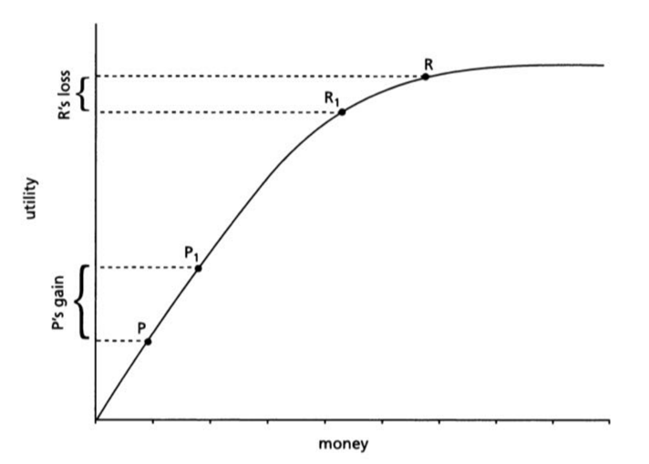
  - It is difficult to compare utility across individuals, since money is not a perfect measure of happiness.

  - Due to the diminishing marginal utility of income, an extra euro means less to a rich person than to a poor one – making money a poor proxy for social welfare.

8. Towards a Less Controversial Version of Utilitarianism: The Pareto Framework and the ‘Ordinalist Revolution’
To address the moral and measurement problems of utilitarianism, economists in the 1920s–1930s adopted a less controversial approach: the Pareto framework, part of what became known as the “Ordinalist Revolution.”

This shift, led by Vilfredo Pareto (1848–1923), marked the transition to modern welfare economics and redefined how economists thought about utility and welfare.

Key elements of the Ordinalist Revolution:
- Interpersonal comparisons rejected:
Interpersonal comparisons of utility and cardinal measurements were no longer considered acceptable.
- Positivist scientific method:
Economics embraced a scientific, behavior-based approach focusing on observable preferences.
- Ordinal measurement of welfare:
Welfare was now measured ordinally – only the ranking of preferences mattered, not their intensity.
- Principle of minimal benevolence:
If Y is better for someone than X, and X is not better for anyone than Y, then (other things equal) Y is morally better than X.

This led directly to the Pareto criteria that underpin welfare economics.

9. Pareto Efficiency and Pareto Improvement
- Pareto Efficiency:
A policy is efficient if it is impossible to make at least one person better off without making someone else worse off.
- Pareto Improvement:
A policy change that makes at least one person better off without making anyone worse off.

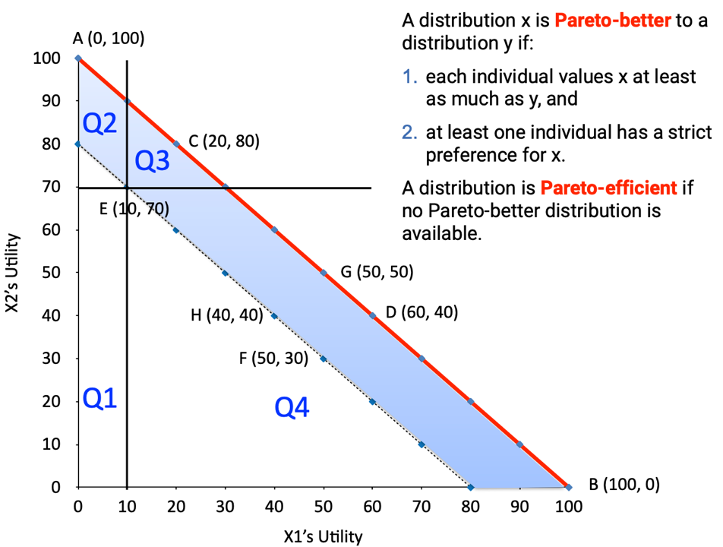

10. Pareto-Comparability
Two allocations are:
- Pareto-comparable if one is Pareto-better than the other (quadrants Q1 and Q3).
- Pareto-incomparable if neither is Pareto-better (quadrants Q2 and Q4).
So:
- Allocations like F and H, F and E, H and E are Pareto-incomparable.
- Even Pareto-efficient allocations (e.g. D and G) may be incomparable.
- Thus, not all Pareto-efficient allocations are better than all Pareto-inefficient ones.
(Graph above)

11. The First Fundamental Theorem of Welfare Economics
Theorem 1:
Under ideal assumptions, competitive markets will always lead to a Pareto-efficient outcome.

This builds on Adam Smith’s hypothesis that individuals acting in their own self-interest promote the public interest through market exchange.
- Consumers seek to maximize preference satisfaction.
- Producers seek to maximize profits.
→ Competitive equilibrium ensures resources are allocated efficiently – no one can be made better off without making someone worse off.
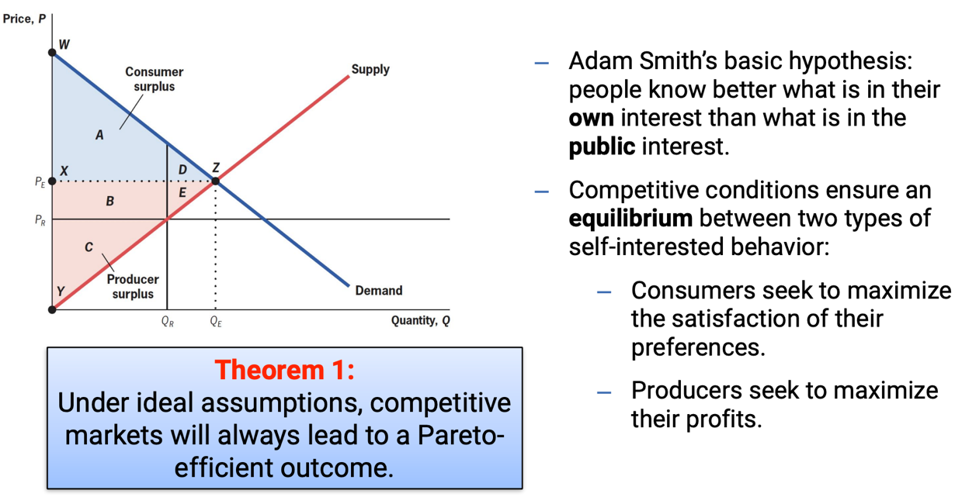

12. The Second Fundamental Theorem of Welfare Economics
Theorem 2:
Society can reach any Pareto-efficient outcome by redistributing initial wealth among individuals and then allowing individuals to freely trade.

This separates efficiency from equity:
- Markets generate efficiency.
- Governments can redistribute wealth (via taxation, transfers, etc.) to achieve more equitable starting points.
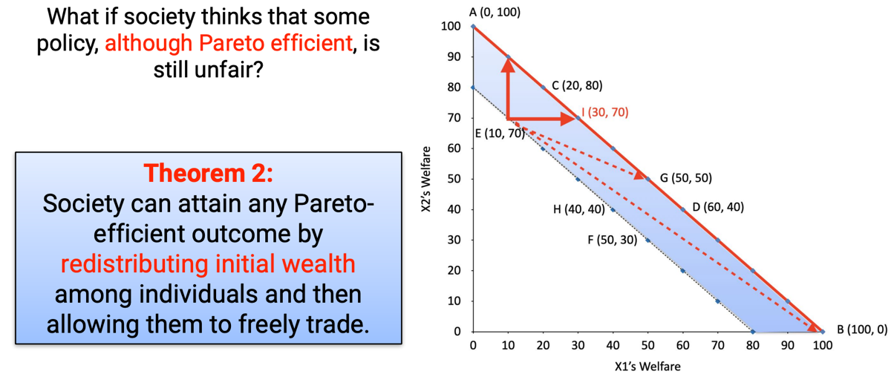

Redistribution example (E → I)

13. Potential Pareto Improvements (Kaldor–Hicks Criterion)
Kaldor and Hicks (1939) proposed a broader test:
A change is a potential Pareto improvement if those who gain could, in theory, compensate the losers and still be better off.

- The “compensation test” focuses on aggregate net benefits, not on whether compensation actually happens. (compensation principle refers to potential efficiency gains)
- This allows policies with winners and losers, as long as total welfare rises.
Example from slides:
- Net Benefit X₁: +40
- Net Benefit X₂: –20
- Total Net Benefit: +20 → potential Pareto improvement.
(Graph above: Welfare improvement from E → G)

14. The Relationship Between the Pareto Framework and Utilitarianism
Although the Pareto framework was developed to avoid the ethical and measurement problems of utilitarianism, it still shares utilitarian roots.
Both are concerned with welfare maximization, but they differ in how welfare is defined and aggregated.

- In utilitarianism, social welfare (W) equals the sum of utilities of all individuals
- The Pareto framework replaces total happiness with preference satisfaction – a “thinner” version of welfare grounded in observed choices, not interpersonal comparison.

Example – Tariffs and Protectionism in the U.S.:
- When the U.S. imposes a tariff, domestic producers gain (area A: producer surplus),
while consumers lose (A+B+C+D).
- There are societal losses (deadweight losses B and D) that outweigh the government’s tax revenue gain (C).
- Hence, tariffs reduce total welfare, showing that protectionist policies are Pareto-inefficient.
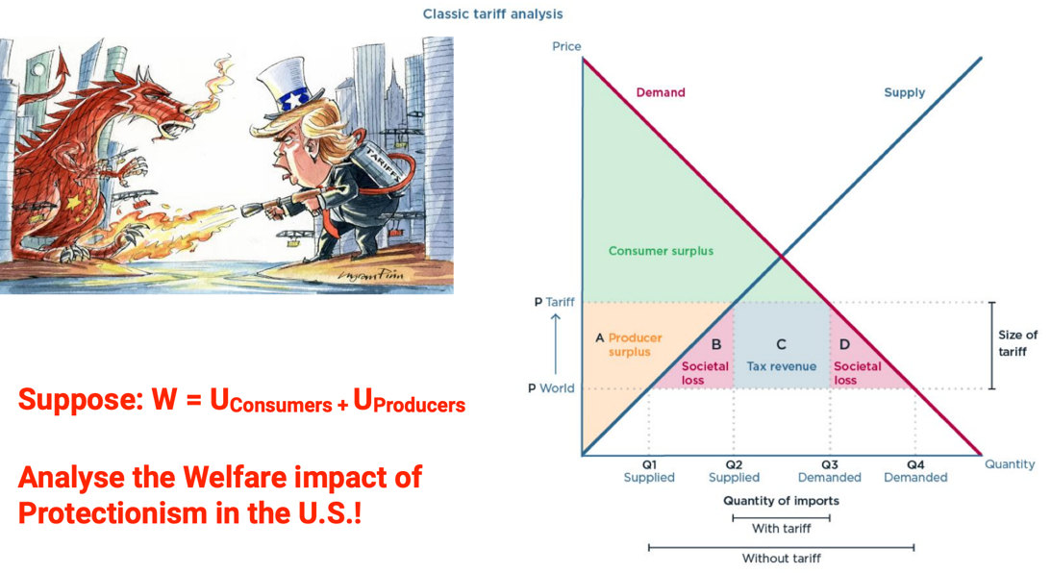
15. Key Upshots
- Efficiency is a fundamental but not exclusive normative goal of public policy. It guides how resources are best allocated, but it is not the only value – fairness, equity, and justice also matter.
- Efficiency regularly collides with fairness.
Policymakers must manage this trade-off, balancing outcomes that maximize total welfare against those that promote equity. This reflects that policymakers – like economists – are also moral philosophers in practice.
- Pareto efficiency is based on a thinner, less controversial philosophical foundation than utilitarianism (remember: minimal benevolence).
It has become the gold standard for assessing a policy’s welfare effects, precisely because it avoids moral and interpersonal judgments.
- In the real world, most policy changes are not perfectly Pareto-efficient, but rather potential Pareto improvements.
This raises an ongoing question: can and will the losers be compensated in practice – or does efficiency come at the cost of fairness?

Reading #5

1. The Problem of Winners and Losers
Even policies that raise average welfare—like free trade under NAFTA—create distributional conflicts. Some groups gain while others lose, making it difficult to define what truly serves the public interest.
A policy is unambiguously in the public interest only if it makes at least one person better off without making anyone worse off — a Pareto improvement.

2. Pareto Definitions
- Pareto dominance: Policy x dominates y if no one is worse off and at least one person is better off under x.
- Pareto improvement: Moving from y to x if x Pareto-dominates y.
- Pareto efficiency: A situation where no further Pareto improvement is possible — any change would harm someone.
These concepts define when a policy outcome can be considered unambiguously better for society.

3. Pareto Efficiency vs. Pareto Improvements
- A Pareto-efficient policy isn’t necessarily an improvement, since moving from one efficient outcome to another might hurt some people.
- Efficiency is a positive concept (what cannot be improved further), not a normative one (what is desirable).
- Only Pareto improvements align directly with the public interest criterion.

4. Policies as Actions and Transfers
Any policy has two components:
- A policy action — the substantive decision (e.g. adopting free trade instead of tariffs).
- A transfer scheme — redistribution among groups (e.g. compensating workers who lose jobs).
This distinction allows policymakers to separate efficiency from equity: the action maximizes efficiency, while transfers address fairness.

5. Quasi-Linearity – Bridging Efficiency and Welfare
Assuming quasi-linear preferences—where each dollar provides the same utility to everyone—creates a direct link between efficiency and welfare.
- Policymakers can first choose the most efficient policy action (maximizing total utility).
- Then use transfers to compensate losers, turning efficiency gains into Pareto improvements.
This connects utilitarian logic (maximize total happiness) with Pareto reasoning (no one worse off).
🟦 Illustration: “Large pie vs. small pie” analogy — the total pie represents total welfare; efficient policies grow the pie, while transfers determine how it’s divided.

6. Limits of the Model (“A Bridge Too Far?”)
The efficiency–welfare link depends on assumptions that rarely hold perfectly in reality:
- Feasible transfers: It may be politically or administratively impossible to compensate losers (e.g. Trade Adjustment Assistance often fails).
- Quasi-linearity: In reality, marginal utility of money varies — a dollar matters more to the poor than the rich.
When these conditions break down, efficient policies may not raise welfare for everyone.

7. Relationship to Cost–Benefit Analysis (CBA)
Cost–benefit analysis reflects utilitarian–Pareto logic:
- Each person’s willingness to pay indicates their change in utility.
- If total benefits exceed total costs, the policy increases total welfare.
However, CBA does not ensure no one is worse off; it assumes that aggregate gains justify individual losses unless explicit compensation mechanisms are built in.

8. Are Pareto Improvements Always “Good”?
Even Pareto improvements rest on consequentialist assumptions — that outcomes, not intentions, define morality.
Other ethical frameworks (e.g. rights-based or virtue ethics) may reject some Pareto-improving policies as immoral (e.g. gun ownership or stem cell research).
Thus, Pareto logic simplifies normative conflict but does not eliminate it.

Lecture 6 – Market Failures

1. Introduction: Market Failure as a Deviation from Efficiency
Market failures occur when the free market fails to allocate resources efficiently, leading to welfare losses or outcomes that are not Pareto optimal. In such cases, individual rational behavior produces results that are socially inefficient, creating a gap between private and social costs or benefits.
The lecture identifies four main types of market failure: externalities, collective action problems, public goods, and information asymmetries (the latter to be covered later).

2. Overprescribing Antibiotics – An Illustrative Case
The overprescription of antibiotics illustrates how individually rational actions can generate collective harm.
Doctors, acting in their patients’ immediate interest, prescribe antibiotics frequently because they are cheap and effective in the short term. However, widespread use leads to antibiotic resistance, harming society at large.
This case exemplifies a conflict between individual and collective rationality – what benefits one person (or their doctor) may reduce the well-being of others through negative externalities.

3. Externalities
Externalities arise when one person’s actions affect another’s well-being outside the market mechanism – meaning these effects are not reflected in market prices.
- Example of an externality: Doctors overprescribe antibiotics, leading to rising antibiotic resistance, which affects others.
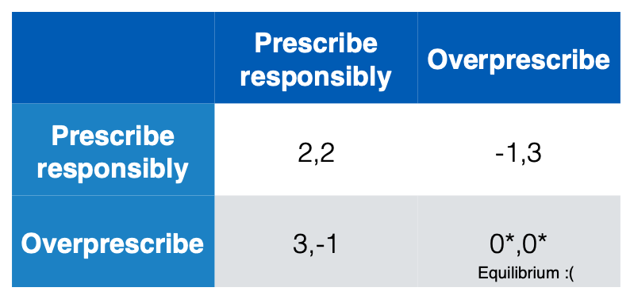
- Not an externality: Overprescription merely bids up medicine prices – this operates within the market mechanism.
The key issue is that external costs or benefits are not internalized – the decision-maker does not bear (or receive) the full consequences of their actions.

4. Why Don’t People Internalize Their Externalities?
(Internalizing = taking external effects into account (so private incentives match social welfare))
Because individuals usually act on private incentives, they fail to account for the social consequences of their behavior. The antibiotic example again shows how short-term, private rationality conflicts with long-term collective welfare.
This misalignment creates market inefficiency – too much of a harmful activity (negative externality) or too little of a beneficial one (positive externality).

5. Externalities as a Social Dilemma
Externalities can be analyzed as a “Prisoners’ Dilemma.”
Each actor’s dominant strategy is to act selfishly (defect), even though mutual cooperation would yield higher overall welfare.
In the antibiotic case, both doctors would be better off prescribing responsibly, but the equilibrium outcome is that both overprescribe.
This dynamic shrinks the utility pie – meaning total welfare is reduced.
- Negative externalities (e.g. pollution, overprescribing) → done too much
- Positive externalities (e.g. education, vaccination) → done too little

6. Negative Externalities
Negative externalities lead to overproduction and overconsumption, as private actors ignore the external costs their actions impose.
- Negative production externalities: Occur when a firm’s production harms others without compensation (e.g. pollution).
- Negative consumption externalities: Occur when an individual’s consumption reduces others’ well-being (e.g. smoking).
The social marginal cost (SMC) is therefore greater than the private marginal cost (PMC), causing the market to produce beyond the socially optimal quantity.
7. Positive Externalities
Positive externalities lead to underproduction and underconsumption, as individuals or firms are not fully rewarded for the benefits they create for others.
- Positive production externalities: When production increases others’ welfare but without compensation.
  - Example: Early oil drillers create knowledge that benefits competitors.
- Positive consumption externalities: When consumption benefits others.
  - Example: Vaccinations protect others by reducing disease spread.
Because social marginal benefit (SMB) exceeds private marginal benefit (PMB), these goods are underprovided in the market.

8. Collective Action
Collective action refers to coordinated group efforts to achieve a common goal that individuals acting alone could not obtain.
However, when contribution is costly (cost = c) and the benefit (B) is shared among N people, the incentive to contribute declines as the group size grows.
An individual’s best response is to contribute only if their incremental benefit exceeds their incremental cost, which becomes less likely in large groups.
Hence, as the number of participants increases, the probability of successfully achieving the collective goal decreases.
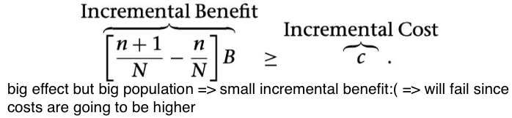

9. The Free Rider Problem
The free rider problem, formalized by Mancur Olson (1965) in Logic of Collective Action, explains why individuals may benefit from a collective good without contributing.
- When costs are concentrated but benefits are dispersed, rational actors refrain from participating, expecting others to bear the cost.
- This reflects a failure to internalize positive externalities of contribution, resulting in “small-pie” Pareto inefficient outcomes.
The problem is especially severe in large groups, though some succeed by appealing to “warm glow” effects – the satisfaction derived from contributing to a public good even without full efficiency (even if it doesn’t fully solve the free rider problem).

10. Public Goods
Public goods exhibit non-excludability and non-rivalry, distinguishing them from private goods:
- Non-excludability: Once provided, no one can be excluded from use (e.g. street lighting, national defense).
- Non-rivalry: One person’s use does not diminish another’s (zero marginal cost of consumption).
However, congestibility may occur when excessive use of public goods introduces negative externalities of consumption (e.g. overcrowded roads).
This combination makes public goods susceptible to free riding, as individuals rely on others to provide them.
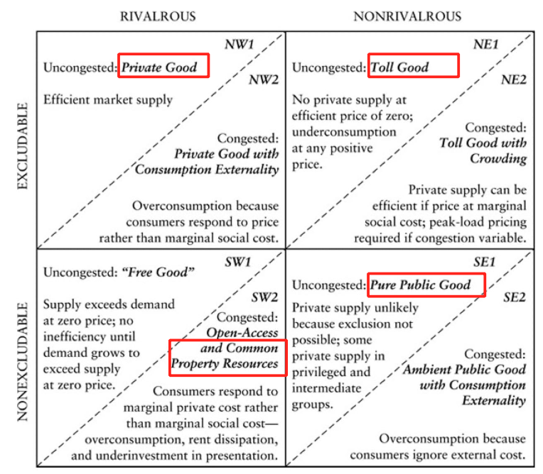

11. Toll Goods
Toll goods are excludable (ownership or access can be restricted) but non-rivalrous in consumption, meaning one person’s use does not significantly reduce the availability for others. Examples include bridges, tunnels, downtown streets, and internet bandwidth.
- When there is no congestion (marginal social cost of consumption, MSCC = 0), introducing any price or toll creates a Pareto inefficiency, because consumers who could benefit without imposing extra cost are excluded.
- However, when congestion occurs (MSCC > 0 after a certain quantity, Q), imposing a toll equal to the congestion cost can restore Pareto efficiency. This is illustrated by congestion pricing schemes such as those in Stockholm or London, which charge users during peak times to internalize the social cost of congestion.

12. Pure Public Goods
Pure public goods are non-excludable and non-rivalrous, meaning that no one can be excluded from their use, and one person’s consumption does not reduce another’s.
Examples include national defense, lighthouses, public broadcasting, Wikipedia, and parts of the Internet.
- Because of non-excludability, public goods are severely affected by collective action problems. The impossibility of excluding free-riders prevents these goods from being supplied by private markets. As a result, markets fail to provide them efficiently, leading to Pareto inefficiency.
- In rare cases, “privileged groups” may privately provide such goods – small, cohesive groups with strong incentives or shared interests can overcome the free-rider problem (e.g., Wikipedia volunteers or local associations funding communal goods).

13. Open-Access (or Common-Pool) Goods
Open-access goods are non-excludable but rivalrous, meaning anyone can use them, but one person’s use reduces availability for others.
Examples include fish stocks, grazing land, irrigation systems, and natural resources like oil or groundwater.
- This situation gives rise to the “Tragedy of the Commons” – when individuals, acting in self-interest, overconsume or underinvest in maintenance, leading to Pareto-inefficient overuse and eventual depletion of the resource.
Since no one can be excluded, individuals have no incentive to conserve, resulting in overexploitation. If usage (Q) must be limited to maintain efficiency, policymakers face the question of who gains and who loses from restrictions (i.e., who bears the cost of limiting access).

13a. The “Tragedy of the Commons” – Hardin (1968)
Garrett Hardin’s influential paper (1968) describes the Tragedy of the Commons as a fundamental moral and institutional problem rather than a purely technical one. Using the example of communal grazing land, he shows how rational individuals acting independently can collectively deplete shared resources.
In the example, farmers decide whether to graze 50 or 100 cows. Each farmer’s dominant strategy is to add more cows, maximizing individual profit even though total welfare declines – ilustrating a Prisoners’ Dilemma.
The equilibrium (both choosing 100 cows) results in lower overall payoffs (4,4) compared to the cooperative outcome (5,5), where each limits usage.
Hardin’s insight emphasizes the need for collective restraint or regulation when managing common resources – technical efficiency alone cannot prevent overuse without moral or institutional limits.

14. Implications of Market Failure for Public Policy
Market failures justify public policy intervention to correct inefficiencies and align private incentives with social welfare. Policymakers face the challenge of designing mechanisms that get individuals to internalize their externalities – that is, to take the full social costs or benefits of their actions into account.
The lecture identifies five main approaches to achieve this:
- Force of persuasion
- Pigouvian taxes and subsidies
- Direct regulation
- Coasian bargaining
- Decentralized self-governance

15. The Force of Persuasion
Persuasion relies on information, education, or moral appeal to convince individuals to internalize externalities voluntarily. Policymakers might attempt to explain that cooperation benefits everyone; however, because the situation resembles a Prisoners’ Dilemma, individuals still have an incentive to free-ride or shirk responsibility.
Even if others contribute to solving the problem, it may not be rational for each individual to do so, since personal gain comes from letting others bear the cost. Therefore, persuasion alone is typically insufficient; more intrusive policy interventions are often required.

16. Tax vs. Regulatory Solutions to Externalities
Price-based instruments (such as Pigouvian taxes or subsidies) make individuals pay or receive compensation equal to the external cost or benefit they impose.
- A Pigouvian tax equal to the marginal damage (MD) of the externality can correct overproduction or overconsumption.
- Such policies are generally efficient, though often considered “second-best” due to imperfect information or political constraints.
A second-best policy maximizes social welfare considering all real-world constraints – it may not be perfect, but it is optimal given existing conditions.

Direct regulation, in contrast, compels firms or individuals to comply with specific limits or standards.
- Without trade, this approach is less efficient, as it may not account for differing costs among firms.
- When combined with tradable permits (“cap and trade”), regulation becomes more efficient, since firms can buy and sell rights to pollute or produce, achieving the same outcome at lower overall cost.

17. Market in Externalities: The Coase Theorem and the Farmer–Rancher Example
Ronald Coase’s Theorem (The Problem of Social Cost, 1960) challenges the view that externalities always require government intervention. It proposes that, under certain conditions, private bargaining can internalize externalities and achieve efficiency on its own.
- Part I: The party causing and the party affected by an externality can negotiate voluntarily to resolve it.
- Part II: If property rights (legal entitlement to use, control, or benefit from a resource) are clearly defined and transaction costs (the costs of negotiating, enforcing, or coordinating an exchange) are negligible, this bargaining will lead to a Pareto-efficient outcome, regardless of who initially holds the rights.

In Coase’s example, a rancher’s cattle damage a farmer’s crops. If B < C, ranching should stop; if B > C, ranching continues but compensation is optimal. Whether the farmer or rancher holds the property right, voluntary bargaining can achieve the socially optimal solution.
However, in reality, high transaction costs, unclear rights, or unequal bargaining power often make such bargaining infeasible – showing why government policies are still needed in most cases.
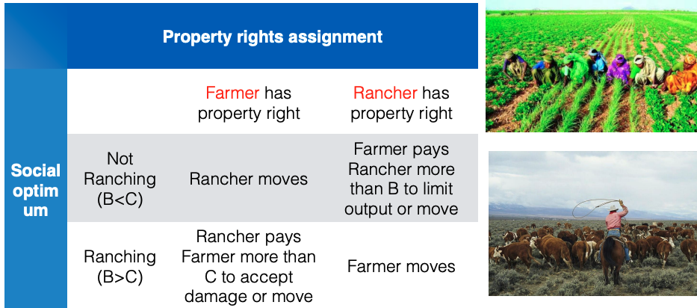

18. Implications of the Coase Theorem
Coase (1960) assumes that property rights are clearly defined and transaction costs are low.
When these hold, private bargaining can internalize externalities efficiently. However, in practice, high costs, unclear rights, or large-scale issues (like global warming) limit this mechanism’s effectiveness.
Coase suggested that governments should focus on reducing transaction costs, creating markets for externalities, and defining property rights more clearly to improve efficiency.

19. Problems with Coasean Bargaining in Reality
In real-world scenarios, such as conflicts over shared spaces or rights (e.g., airplane seat disputes), Coasean bargaining often fails because rights are ambiguous, information is incomplete, or transaction costs are high.

20. Self-Governance: Elinor Ostrom’s Contribution
Elinor Ostrom (1990) argued that the “Tragedy of the Commons” is not inevitable. Communities can successfully manage common-pool resources through collective self-governance rather than relying solely on state control or privatization.
Her research showed that when stakeholders can communicate, monitor resource use, and create rules fitting local conditions, they can prevent overuse.
Ostrom’s Design Principles
Effective self-governance requires:
- Clear boundaries and local rule-making.
- Collective decision-making and monitoring by users.
- Graduated sanctions and conflict-resolution mechanisms.
- Recognition of local institutions and multi-level governance.
These features promote cooperation and sustainability.

Examples like community-managed irrigation systems in Switzerland and global internet governance (ICANN) illustrate how shared resources can be successfully managed through institutional design and cooperation.

21. Key Takeaways
- Externalities cause deviations from Pareto efficiency, justifying policy intervention.
- Public goods are often undersupplied or overused without collective action.
- Market failures provide a rationale for government involvement, but Coase and Ostrom show that limited state intervention can sometimes work.
- Successful self-governance depends on institutional arrangements that lower transaction costs and align incentives.

Reading #6
The reading reinforces that policy analysis seeks to improve public decision-making by identifying when markets fail to produce efficient or equitable outcomes.
Market failures arise from externalities, public goods, information asymmetries, and imperfect competition, all of which justify potential government intervention.

Weimer and Vining stress that interventions should only occur when their benefits exceed administrative and compliance costs, recognizing that governments themselves may fail through inefficiency or poor incentives.

They also revisit Coase’s idea that clearly defined property rights and low transaction costs can enable private bargaining to internalize externalities, and Ostrom’s finding that communities can design effective self-governance institutions.

Overall, the reading complements the lecture by framing market failure not as automatic justification for state action but as a signal to assess the most efficient institutional response – whether through the market, government, or collective self-organization.

Lecture 8 – Fairness

1. Inequality and Redistribution
Income inequality has shifted considerably across the 20th and 21st centuries. The graph on top income shares (1900–2023) shows a decline in inequality during the mid-20th century, followed by a sharp rise since the 1980s, particularly in Anglo-Saxon countries.
Similarly, top marginal tax rates fell significantly after 1980, reflecting changing political and economic priorities.

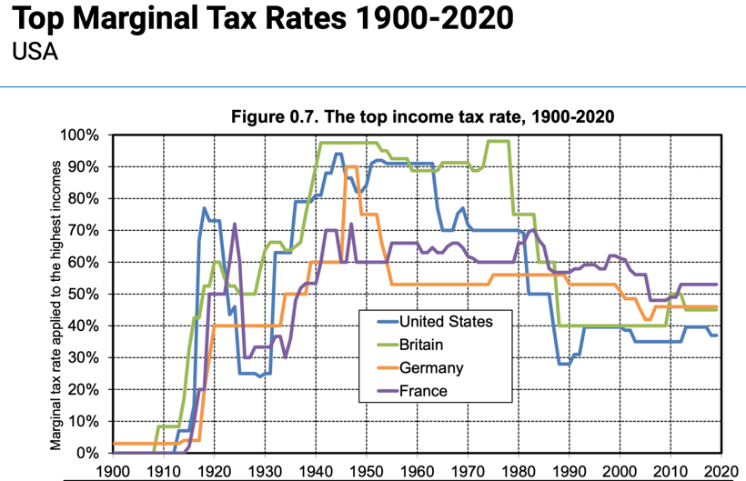
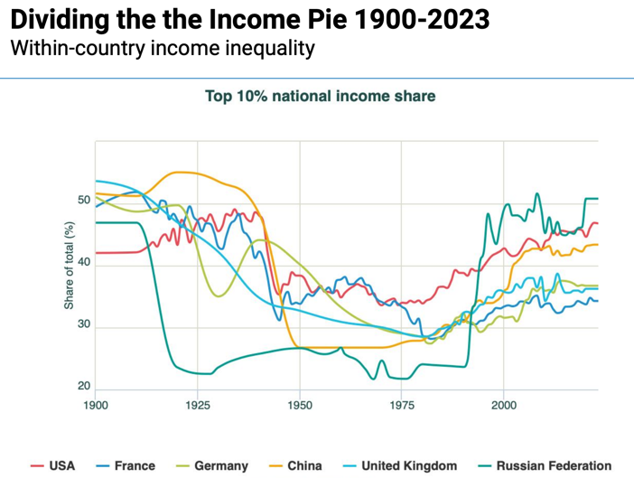
The OECD redistributive spending graph highlights large differences in government transfers: Nordic and Western European countries spend the most relative to GDP, while Mexico and Turkey spend the least. (Graph of public social spending as a % of GDP)

2. Welfare State Regimes
Three main welfare models represent distinct ideological conceptions of fairness:
- Liberal Regimes (e.g., U.S., Canada, Australia):
Stress individualism and market mechanisms. Welfare is limited and targeted, acting mainly as a safety net.
- Corporatist Regimes (e.g., Germany, France, Italy):
Tie welfare to employment and family roles, reinforcing traditional social structures and preserving class hierarchy.
- Social-Democratic Regimes (e.g., Sweden, Denmark, Norway):
Promote universal rights and equality through extensive public welfare and redistribution, aiming for decommodification – reducing dependence on the market for
security.

These regimes illustrate how different societies balance state responsibility, solidarity, and efficiency in the pursuit of fairness.
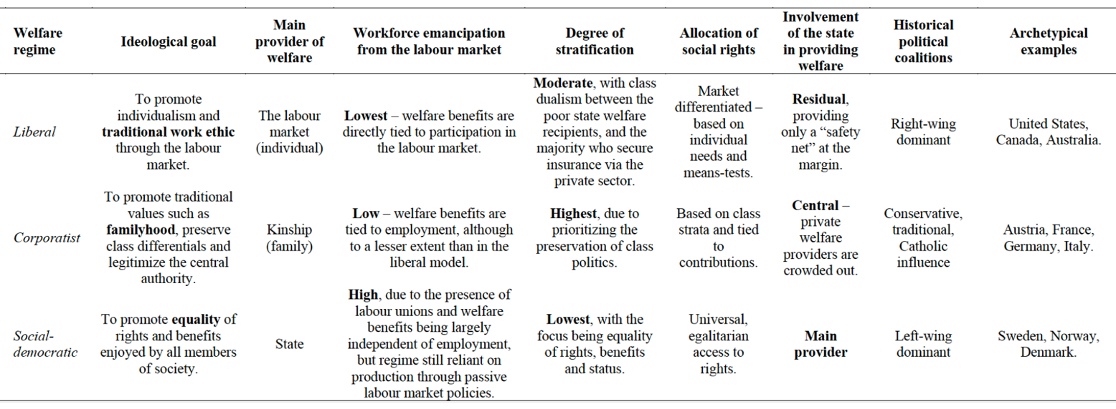

3. Efficiency–Fairness Trade-off
Public policy constantly faces a tension between efficiency (maximizing total welfare) and fairness (distributing welfare equitably).
- Equality provides the same outcomes to everyone.
- Equity adjusts outcomes based on differences in need or contribution.


4. Individual Inequality Aversion
Individuals often prefer fairer outcomes even at a personal cost. This tendency is called inequality aversion.
- Disadvantageous inequality: discomfort from earning less than others.
- Advantageous inequality: discomfort from earning more than others.

The Fehr–Schmidt model expresses this through:
- α (alpha): sensitivity to being worse off,
- δ (delta): sensitivity to being better off (where δ < α).

5. Social Inequality Aversion and Welfare Functions
At the collective level, social welfare functions (SWFs) express how societies value the distribution of welfare.
The isoelastic SWF introduces the inequality aversion parameter (η), which captures how the marginal utility of income declines as income rises.
- Higher η means stronger preference for equality and redistribution.
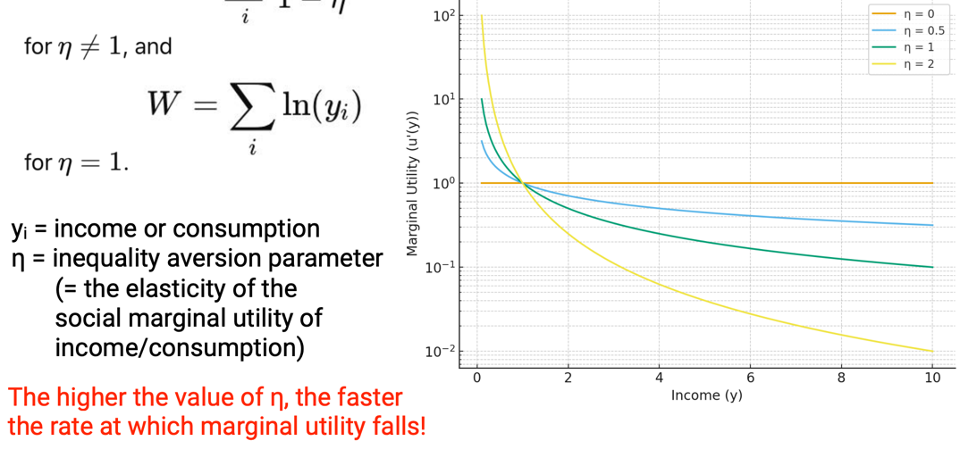

5. Social Indifference Curves
Different SWFs reflect varying societal attitudes toward inequality:
- Utilitarian (η = 0): No inequality aversion; maximizes total welfare.
- Weighted Utilitarian (η > 0): Some inequality aversion; balances fairness and efficiency.
- Rawlsian (η → ∞): Complete inequality aversion; maximizes welfare of the least well-off (max–min principle).
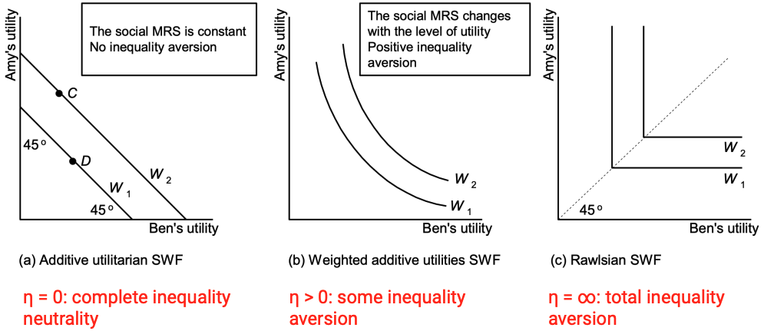

6. John Rawls’s Theory of Justice (1971)
John Rawls, a U.S. liberal analytical philosopher, presented one of the most influential accounts of a just society. His Theory of Justice (1971, rev. 1999) defines liberal egalitarianism, emphasizing fairness as the moral foundation of institutions.
Rawls argues that inequalities are acceptable only if they benefit everyone, especially the least advantaged. His ideas remain central to contemporary debates on redistribution and the moral justification of welfare policies.

7. Rawls’s Two Principles of Justice
- Equal Liberty Principle
Every individual has an equal right to the most extensive system of basic liberties compatible with the same liberties for all.
- Difference Principle and Fair Equality of Opportunity
Economic and social inequalities are acceptable only if they
  - are attached to positions open under conditions of fair equality of opportunity, and
  - work to the greatest benefit of the least advantaged.
→ This second condition is the Difference Principle, prioritizing improvement of outcomes for society’s poorest members.

8. The Original Position and the Veil of Ignorance
Rawls’s thought experiment imagines people designing social rules without knowing their own future status, wealth, or talents.
Rational actors would choose institutions that make the worst-off position as good as possible, ensuring fairness regardless of personal circumstance.
This reasoning leads to the maximin rule – maximizing the minimal (worst possible) outcome.

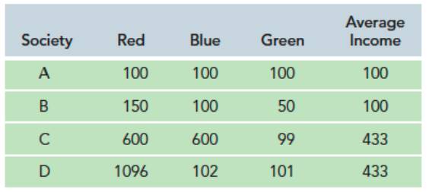
• Rawls prioritizes fairness → chooses D (best for the least advantaged).
• Bentham prioritizes efficiency → chooses C or D (highest total welfare).

9. The “Leaky Bucket” Experiment (A. Okun, 1975)
Arthur Okun illustrated the efficiency–equality trade-off using the metaphor of a leaky bucket: transferring €1 from a rich person to a poor person loses some value due to
- administrative costs,
- deadweight loss from taxation, and
- moral hazard (reduced labor supply).
If a society exhibits strong inequality aversion, it accepts higher “leakage” because the welfare gain to the poor outweighs efficiency losses.

10. Policy Implications of Inequality Aversion
Balancing fairness and efficiency guides practical policymaking.
The slide comparing Bentham, Pareto, and Rawls links economic efficiency with moral perspectives:
- Bentham: maximize total utility (utilitarian).
- Pareto: accept only improvements that make someone better off without hurting others.
- Rawls: prefer distributions improving the position of the least advantaged (difference principle).

11. Policies That Increase Both Efficiency and Fairness
Examples discussed include:
- Strengthening antitrust laws.
- Regulating executive compensation in finance.
- Enhancing transparency in lobbying.
- Reforming tax policies (e.g., capital gains).
- Improving public education and health literacy.
These policies aim to reduce structural inequality while enhancing productivity.

12. Case Study: Health Literacy
According to the World Health Organization, health literacy involves the cognitive and social skills that enable individuals to access, understand, and use information to maintain good health.
The cross-country comparison shows large disparities: countries like Latvia and Lithuania have high shares of inadequate or problematic health literacy, while Netherlands and Germany perform better.

Efficiency Costs of Low Health Literacy:
- More frequent doctor visits and hospitalizations.
- Longer hospital stays and higher emergency use.
- Under-utilization of preventive care.

Equity Costs of Low Health Literacy:
- Unequal access to health information and outcomes.
- Evidence suggests literacy mediates socio-economic disparities in health (education, age, income, race/ethnicity).
→ Thus, improving health literacy enhances efficiency (reducing healthcare costs) and fairness (equalizing health outcomes).

13. Key Takeaways
- The intersection between efficiency and equality is non-empty. Both can be improved jointly.
- Liberal egalitarians accept inequalities if they work to the advantage of people who happened to be born at the wrong time in the wrong place with the wrong skills & talents.
- How exactly efficiency and equality will be combined in public policy is unavoidably a matter of politics. The contribution of the economist is to identify and set straight the relevant trade-offs.

Reading #8

1. Social Welfare Functions (Beyond Pareto)
The reading expands on welfare evaluation by introducing explicit social welfare functions, which go beyond Pareto-efficiency.
New concepts include:
- Utilitarian welfare function: sums utilities. It reflects the “greatest good,” not “the greatest good for the greatest number.” It underlies cost–benefit analysis.
- Rawlsian (maximin) welfare function: evaluates allocations based on the welfare of the worst-off individual. Strongly redistributive.
- Multiplicative welfare function: avoids very low individual outcomes by penalizing near-zero utilities.
Key idea: Pareto efficiency alone cannot tell us which efficient allocation is “best.” Welfare functions impose ethical structure on ranking outcomes.
The reading also highlights practical problems: utilities cannot be observed, interpersonal comparisons are impossible, and society cannot agree on a single welfare function.
This is new relative to the slides: the reading engages deeply with the limitations and conceptual challenges of using welfare functions in real policy analysis.

2. Institutional vs. Allocation-Based Views
A major new insight: instead of deciding the best allocation directly, society can choose the institutions that generate allocations.
This includes:
- Constitutional design perspective: norms and procedural rules matter more than individual policy outcomes.
- Rule utilitarianism: an act is correct if it adheres to rules that maximize long-term social utility, even if the act alone is not utility-maximizing.
Example:
Giving disaster relief may increase short-run welfare (act utilitarianism), but may create future moral hazard, making it undesirable under rule utilitarianism.
This focus on how institutions shape incentives is a major conceptual expansion not covered in lecture slides.

3. Human Dignity and Minimum Consumption Floors
The reading develops equity of opportunity and consumption floors much more fully than the slides.
New ideas:
- Ensuring dignity may require guaranteed minimum consumption, not equality.
- Participation in markets requires a minimum endowment of assets, otherwise individuals have “no choice” in practice.
- Policies such as job training, remedial education, and anti-discrimination laws expand effective participation, not just redistribute wealth.
The reading also discusses paternalism (e.g., preventing children or impaired adults from harming themselves) as part of protecting human dignity — also not in slides.

4. Equality of Outcomes – Dynamic Problems
The reading expands on equality with concepts not in slides:
- Equality of outcomes must consider incentive effects — full equalization destroys incentives and shrinks total wealth.
- CEO compensation explosion and bargaining problems are framed as public goods problems:
  - Weak unions → underprovided worker bargaining
  - Dispersed shareholders → under-monitored executives
- The “leaky bucket” metaphor (Okun): redistribution loses efficiency the more you try to reallocate.
All of these are new and deepen understanding of redistributive policies.

5. Measurement and Index Problems
The reading adds a large set of technical issues that the slides don’t cover:

Income measurement issues
- Imputed income from owner-occupied housing.
- Distortions from tax deductions, in-kind transfers, and means-testing.
- The mismatch between household income vs. per capita income, especially due to demographics (divorce, women’s labor force participation).

Inequality indices
- The Gini coefficient and the Lorenz curve are explained in detail.
- When Gini is not appropriate: sometimes we care only about the poor, not the whole distribution.
- Alternative measures:
  - income share of lowest quintile
  - cost of eliminating poverty
These problems matter because distributional analysis depends on correct measurement, not just moral judgment.

6. Categorization & “Silent Losers”
New and important concepts:

Categorization problems
Group comparisons (e.g., by race or gender) may mislead because groups differ on many dimensions (education, age structure, family size).

Silent losers
A major conceptual addition: some groups harmed by policy remain unseen because they:
- Don’t know they’re harmed
(future renters under rent control)
- Don’t connect the harm to the policy
(workers losing jobs due to oil price controls)
- Don’t yet exist
(future generations under climate change)
Slides do not cover this but it is crucial for realistic policy analysis.

7. Instrumental Values – Political Feasibility & Budget
The reading elaborates on instrumental values:
- Political feasibility often shaped by distributional consequences, even when those distributions don’t match any moral theory.
- Expenditure levels have symbolic meaning (“war on drugs” spending).
- Agencies face strict resource constraints, shaping policy design independently of values.
This is new: slides touched on values but not on instrumental constraints.

Lecture 9 – Government Failures

1. Why Governments Fail
Governments are expected to promote the social good by choosing and implementing efficient and fair policy alternatives. However, real political systems face structural limits and incentive problems. Policymaking is embedded in institutions that can distort outcomes, preventing government from acting like a benevolent “social planner.”
Failures arise when preference aggregation, political incentives, or administrative structures prevent policies from reflecting coherent social preferences or maximizing welfare.

2. Main Drivers of Government Failure

2.1 Preference Aggregation Problems
Public decisions require aggregating individual preferences into a single social preference or rank ordering of alternatives. A theoretical social welfare function (SWF) is supposed to take individual inputs and produce a consistent social choice that represents the “will of the people.”
However, aggregation is often incoherent. Different procedures can produce intransitive social preferences, meaning society prefers X to Y, Y to Z, and Z to X.
When the collective outcome violates transitivity, there is no stable social choice, and the government cannot clearly identify what society wants. This creates a fundamental government failure because even fully democratic input cannot guarantee coherent output.

2.2 Rent Seeking
Organized interests attempt to secure non-market rents – advantages obtained not through productive efficiency but through influence over the political process.
They use lobbying, meaning they try to shape policy alternatives or the government’s rank ordering of options by applying political pressure.
Rent seeking diverts public resources toward narrow interests, reducing overall welfare and distorting policy priorities away from the social good.

2.3 District-Based Representation
Because elected officials represent geographical districts, they have incentives to prioritize local rather than national welfare.
This leads to pork-barrel spending: politicians support projects (bridges, subsidies, local construction) that benefit their constituency even if the policy alternative is inefficient from a national perspective.
When all representatives behave this way, the result is excessive spending on low-value projects driven by distributive competition rather than coherent social preferences.

2.4 Policy Myopia
Decision-makers operate within short electoral time horizons.
They prefer policy alternatives that provide immediate, visible payoffs and underestimate the value of long-term benefits.
This produces systematic underinvestment in areas like climate mitigation, infrastructure, and preventive health – failure caused by the temporal structure of political incentives.

2.5 Bureaucratic Failure
Bureaucrats may have different objectives than elected officials.
Their incentives can favor budget maximization, risk avoidance, or administrative expansion rather than efficient policy implementation.
Misalignment between political goals and bureaucratic behavior reduces policy effectiveness and generates inefficiencies even when the selected policy alternative is socially desirable.

2.6 Fiscal Externalities
Local jurisdictions compete for mobile taxpayers by reducing taxes, generating a race to the bottom.
Individually, each district benefits from lower tax burdens, but collectively these choices create negative externalities by shrinking the national tax base and undermining the provision of essential public goods.

3. Preference Aggregation in Practice
The lecture shows that specific decision rules fail to produce stable or fair social preferences.

3.1 Pairwise Majority Voting (PMV)
PMV compares policy alternatives two at a time.
Although intuitive, PMV can generate Condorcet cycles, where pairwise majorities conflict.
Example:
- A majority prefers X > Y
- A majority prefers Y > Z
- A majority prefers Z > X
The resulting social preference is intransitive, so the collective ranking cannot guide consistent policy.
Agenda-setters can exploit this by structuring the sequence of votes to manipulate outcomes.

3.2 Borda Count
Here, alternatives receive points according to their rank positions (If there are k alternatives, each person’s first choice gets k−1 points, each person’s second choice gets k−2 points, and so on, with each person’s last choice getting 0 points). The alternative with the highest point total wins.
Although Borda Count produces a complete rank ordering, it violates Independence of Irrelevant Alternatives (IIA): the social ranking between X and Y can change simply because voters reorder irrelevant alternatives (like Z).
This makes outcomes sensitive to strategic manipulation of ballots and undermines the reliability of the resulting social preference.

4. Criteria for a “Good” Aggregation Procedure

4.1 Transitivity
A well-functioning aggregation rule must yield transitive social preferences.
If society’s ranking becomes cyclical, the “public will” is undefined, and policy becomes unstable => social preference is intransitive (Condorcet Paradox)

4.2 Unanimity
If every individual prefers X to Y, the social preference must also rank X above Y.
However, procedures such as sequential run-off voting (in each round, one alternative is eliminated, and the winner moves on to face the next alternative. The final social choice depends on the sequence of comparisons) can violate unanimity, because an alternative preferred by everyone can still lose if the sequence is unfavorable.

4.3 Independence of Irrelevant Alternatives (IIA)
Preferences between X and Y should not depend on positions of irrelevant alternatives (Z).
Violations of IIA – as shown in the Borda Count examples – demonstrate how easily collective decisions can be distorted.
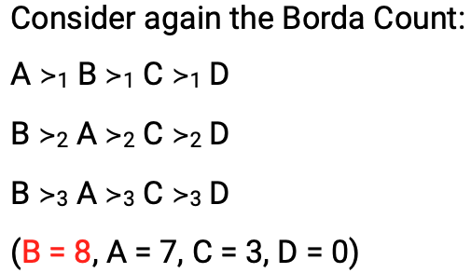
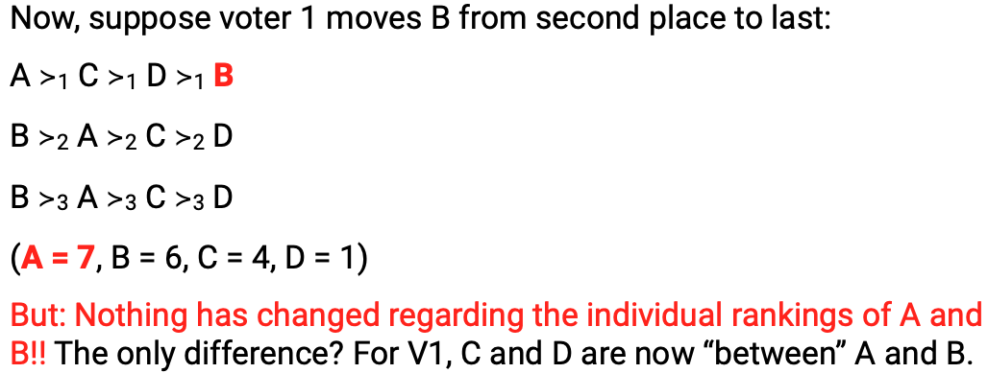

These problems illustrate why aggregating preferences into a single social welfare function is not straightforward.

5. Arrow’s “General Possibility Theorem”
Arrow’s theorem asks a fundamental question: Which aggregation procedure guarantees a coherent social preference?
A social welfare function (SWF) aggregates individual preferences into a social preference, ideally satisfying three key conditions that define a “good” rule:
- Transitivity (if society prefers x > y and y > z, it must prefer x > z).
- Unanimity (if everyone prefers x > y, society must rank x > y).
- Independence of Irrelevant Alternatives (IIA) (the ranking between x and y should depend only on preferences over x and y).

Arrow’s theorem states:
If there are at least two people and at least three policy alternatives, no non-dictatorial social welfare function can satisfy transitivity, unanimity, and IIA simultaneously.
This means that even when individuals have rational, transitive preferences, once we aggregate them, social preferences may become intransitive (preference cycles).
This challenges the idea of a coherent “will of the people.”

The slides highlight that democracy can produce cycles, implying that majority voting does not always generate stable or rational outcomes.
The mention of William Riker and the “social choice” critique emphasizes that democratic outcomes can be strategically manipulated due to agenda setting.

6. Real-World Example: Brexit Preference Cycles
The Brexit polls (Remain, May Deal, No Deal) show a real-world instance of cyclical social preferences, mirroring Arrow’s theorem:
- R > D (Remain beats No Deal)
- N > R (No Deal beats Remain)
- D > N (May Deal beats No Deal)
This is a Condorcet cycle: every option is beaten by another.
Even with millions of voters, society may not have a single, stable “top choice.”
This illustrates that preference aggregation problems are not abstract – they occur in major policy debates.

7. Rent Seeking
Rent seeking occurs when actors gain economic benefits by influencing the policy process, rather than through competitive markets.
This includes activities like:
- lobbying for tariffs
- occupational licensing
- quotas
- subsidies
Rent seeking is injurious to the vast majority because benefits are concentrated, while costs are diffuse.

This ties into Wilson’s typology:
- Interest group politics (concentrated benefits, concentrated costs)
- Clientelistic politics (concentrated benefits, diffuse costs)
In clientelistic politics, a small group receives large benefits, while society bears small but widespread costs.
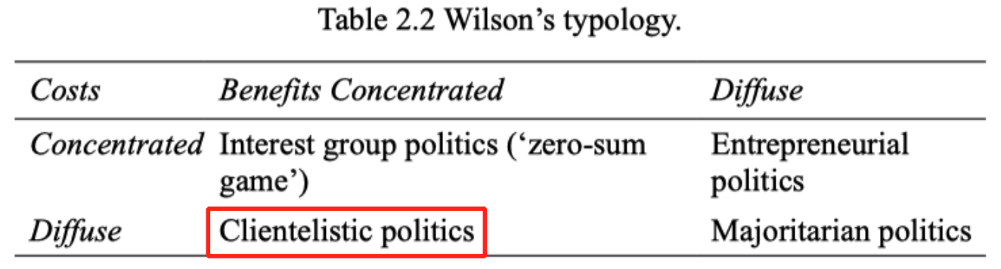

8. Rent Seeking Through Tariffs
The tariff diagram illustrates how domestic producers obtain a rent (area A) due to artificially higher prices.
However:
- Areas B and D represent societal losses that are not recouped.
- Area C is tax revenue, but still insufficient to offset total losses.
- Retaliation by trade partners may eliminate even the producers' rent.
Thus, tariffs are inefficient and classic examples of policy distorted by rent-seeking interests.
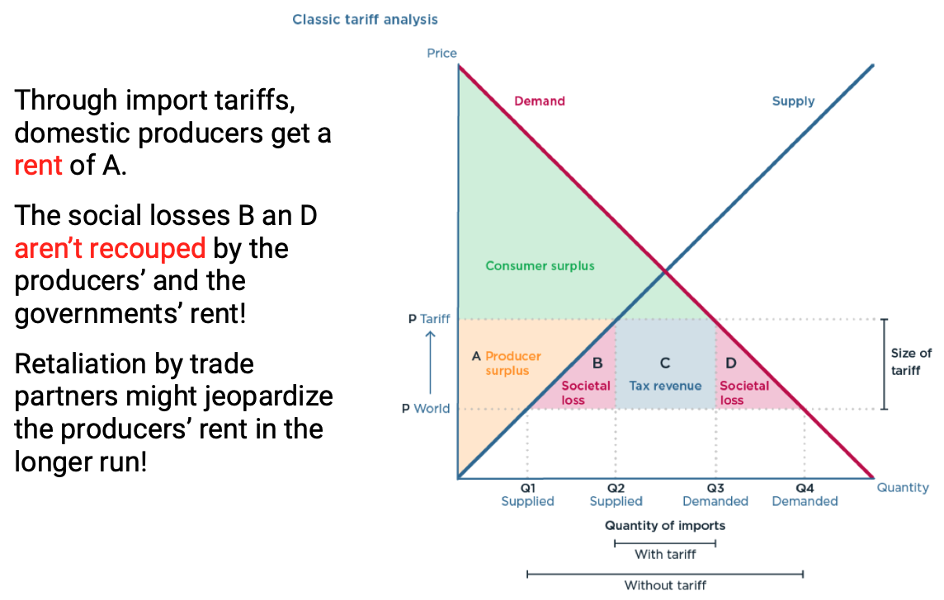

9. Rent Seeking Through Price Floors
A price floor at Pₛ gives producers a rent equal to area PₛP₀cd.
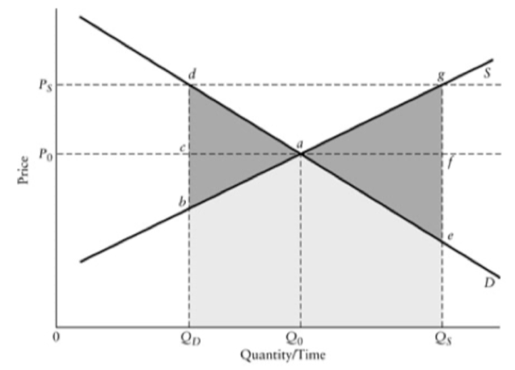
But the welfare impacts depend on how the government handles excess supply:
- Production quota → welfare loss = –abd
- Government purchase + distribution → –aeg
- Government purchase + destruction → –QdagQₛ

Transitional Gains Trap:
Even if a policy is harmful, removing it may hurt current beneficiaries (e.g., landowners), making reform politically difficult.
This is a classic government failure driven by political constraints.
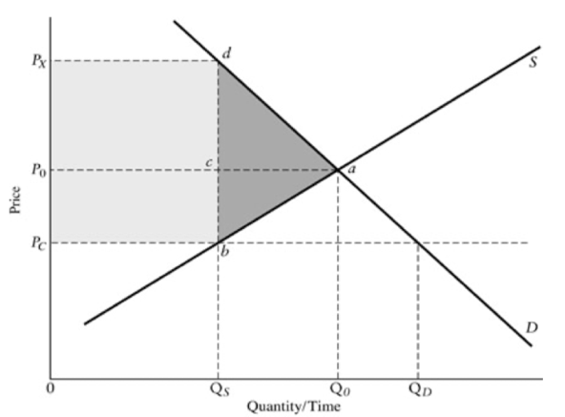

10. Rent Seeking Through Price Ceilings
With a price ceiling at P₍c₎, consumers receive a rent of P₀P₍c₎bc.
But the welfare impact is negative:
- Best case: loss of consumer + producer surplus.
- Worst case: consumers dissipate their surplus by spending time/effort fighting for scarce goods (e.g., waiting lines).
The slides highlight a fairness impact question:
A policy intended to help consumers often ends up being inequitable, because access goes to those with time, connections, or luck.

11. Key Takeaways
- Public policy is not made by a Pareto improving machine. Policymakers operate with limited information and incentives.
- Government failure arises from technological and incentive constraints.
- Even well-intentioned interventions may fall short of correcting market failures.
- Policy is a second-best environment—outcomes cannot be judged against ideal theoretical benchmarks.
- To understand real policy outcomes, one must understand the politics of the policymaking process.
- Leaders must work within constraints from both markets and government.

Reading #9

1. The Deep Logic of Government Failure Is Multi-Layered
The text emphasizes that unlike market failure, there is no single unified theory of government failure. Instead, the analyst must stitch together insights from:
- Social choice theory (voting rules → incoherence)
- Public choice theory (self-interested representatives)
- Organizational behavior (bureaucratic incentives)
- Fiscal federalism (coordination issues in decentralized systems)
Your slides mention only high-level political failures — the reading gives a richer analytical architecture behind them.

2. Sophisticated voting
This is NOT in your slides, but the book stresses it as a crucial extension of the paradox of voting.
- Voters may lie about their true preferences in early rounds of sequential voting
- The goal: manipulate the agenda so that the final outcome is closer to their preferred option
- This can completely overturn “the will of the people” even more dramatically than the basic Condorcet cycle
This expands the slide concept of agenda control by showing that manipulation does not require power — just strategy.

3. Preference Intensity Problem
Voting systems cannot express intensity — only rank order.
A majority that cares slightly about an issue can politically defeat a minority that cares enormously.
This produces:
- Pareto-inefficient outcomes
- Policies where total harm > total benefit
- “Tyranny of the majority”
Slides mention “majority rule issues,” but not this deeper mechanism.

4. Bundling problem in elections
Not in slides, but critical.
Because representatives offer policy bundles, a winning candidate might:
- Hold the minority position on every single issue
- Still win because different groups support different parts of the bundle
This directly undermines the slide concept of “rank ordering alternatives” because voters choose bundles, not individual policies.

5. Legislative Myopia (Short Time Horizons)
The reading introduces a sharp insight:
- Representatives discount the future more heavily than society does
- They prefer policies with visible short-run benefits and long-run hidden costs
This is linked to elections, not part of your slides, and helps explain:
- chronic budget deficits
- underinvestment in long-term infrastructure
- overinvestment in short-term pork

6. Sunk-Cost Political Trap
Economists ignore sunk costs.
Politicians do not.
Because:
- admitting mistakes is punished
- abandoning ongoing projects looks like failure
- “We’ve already spent so much!” becomes a political argument
This is a political pathology that slides do not discuss, but it deeply distorts policy evaluation.

7. Policy Windows & Agenda Surfing
The reading (via Kingdon) adds detail missing from the slides:
- Politicians wait for “windows” created by media attention or shocks
- They often propose symbolic or rushed policies simply to appear responsive
- The agenda is driven by media salience, not social value
Thus, social welfare functions are disrupted not only by voting flaws but by attention cycles.

8. Rent-seeking costs include dissipation
Slides mention rent-seeking but the reading gives deeper mechanisms:
- Competing interest groups may spend resources equal to or greater than the value of the rents
- So the net social waste can exceed the rent itself
- Transitional gains trap: once rents get capitalized into asset values (e.g., farmland prices), removing the rent harms innocent owners
This explains persistent inefficiency far beyond the slide explanation.

9. Silent Losers Problem
A new idea: when costs are:
- diffuse
- delayed
- hard to observe
…then the harmed group never mobilizes, even though total harm exceeds total benefit. Examples include:
- price ceilings
- environmental regulations that raise unemployment
- industry-specific subsidies
This explains the political invisibility of social cost, missing from the slides.

10. Principal–Agent Problem in Bureaucracies
Slides mention bureaucratic inefficiency, but the reading adds:
- Agencies maximize slack, not budgets (extra staff, perks, low workload)
- They hide discretionary budgets because returning funds would reveal true costs → budget cuts
- Public agencies cannot be disciplined by competition or profit motives
This is a deeper explanation than the slides’ simple “bureaucracy is inefficient.”

11. Output valuation problem in public agencies
Because public goods (e.g., national security, safety) have no market price:
- It is hard to measure benefits
- Hard to set optimal budgets
- Impossible to reward bureaucracies based on performance
This is a structural failure, not mentioned in slides.

12. Distributional Complexity of Public Outputs
Private firms ignore who buys their goods.
Public agencies must care.
Conflicts arise between:
- efficiency
- horizontal equity
- vertical equity
Public programs must simultaneously optimize multiple social welfare function criteria → practical impossibility.

